
info@argusoft.com www.argusoft.com

Technical Proposal
A proposal for Assignment

System design, development, and support and maintenance of the Data Management System for Health Accounts.
Ref : PFD -2026-001

Submitted on
12th August, 2026

WHO

Table of Contents
Table of Contents 2
Cover Letter 4
Executive Summary 6
Compliance Matrix - Mandatory Requirements 8
Relevant Experience (Past Project References) 11
Technical Proposal / Methodology Proposed in the Proposal 25
Scope of Work - Our Understanding 25
Our Differentiated Value 29
Approach 33
Methodology 39
Proposed Solution 40
Important Modules 45
Proposed Tech Stack 59
Hosting 60
Proposed Work Plan 62
Development Timeline 67
Quality Assurance Methodologies and Processes 68
Coding Standards and Cybersecurity Measures 70
Capacity Building and Knowledge Transfer 72
Support, Maintenance, and Help Desk Services 76
Key Personnel 78
Resumes of Key Resources 82
Annex - 1 : Case Studies 131
CASE STUDY 1 : Transport Authority — License Management Portal 131
CASE STUDY 2 : CHiP — Community Health Information Platform 140
CASE STUDY 3 : ImpactHealth Nigeria & iMoMCare Cambodia — MEDPlat Multi-Country Field Deployments 150
CASE STUDY 4 : Administrator General's Dept — Trust & Estate Management System 160
CASE STUDY 5: TENN Livelihood Innovation Programme 171
Resilient Microbusinesses (RMBs) — Kasirie & Kambia Town 174
Fisheries Value Chain — Artisanal Fisherwomen, Kasirie 175
Onion Value Chain — 'Come See Women Farmers' Cooperative, Lungi 175
Poultry Value Chain — Poultry Farms, Newton, Western Area Rural 176
Annex - 2 : Company Profiles 182
About Argusoft India 182
About TENN 188

Cover Letter
Date: 12th August, 2026
To
The Procurement Committee
World Health Organization (WHO)
Subject: Proposal Submission – Development of the Health Accounts Data System (HADS), built upon WHO’s existing xMart data warehouse (Reference: PFD-2026-001)
Dear Sir/Madam,
Argusoft India Limited is pleased to submit its Technical and Financial Proposal for the Development of the Health Accounts Data System (HADS), built upon WHO’s existing xMart data warehouse . We appreciate the opportunity to partner with the World Health Organization (WHO) in delivering a secure, scalable, and configurable platform that strengthens the collection, validation, management, and analysis of National Health Accounts data across Member States.
We recognize that National Health Accounts are fundamental to evidence-based health financing and health system governance. Reliable Health Accounts data enables governments to monitor health expenditure, evaluate financing reforms, support Universal Health Coverage (UHC), and make informed policy decisions. Through this initiative, WHO is modernizing its digital ecosystem to improve data quality, standardization, collaboration, and analytical capabilities. We are committed to delivering a sustainable platform that contributes to stronger national health information systems and better health financing decisions worldwide.
For over 24 years, Argusoft has been delivering enterprise digital transformation solutions for governments, international organizations, and public sector institutions. Our expertise includes configurable enterprise platforms, metadata-driven applications, workflow automation, analytics, cloud-native architectures, secure software engineering, interoperability, and long-term application support.
Argusoft has built a strong partnership with the World Health Organization through the successful delivery and ongoing support of several strategic digital platforms. Our WHO portfolio includes the Joint External Evaluation (JEE) Reporting Platform, Early Warning, Alert and Response System (EWARS), Event Management Suite (EMS2), Simulation Exercise (SimEx), WHO Emergency Public Dashboard, and the P4H World Platform, which supports global collaboration on social health protection and health financing. These engagements have provided us with a deep understanding of WHO's digital ecosystem, delivery standards, cybersecurity requirements, and collaborative implementation approach.
Equally important, Argusoft has extensive experience implementing national-scale Health Information Systems, directly aligning with the objectives of this assignment. Our portfolio includes TeCHO+, serving over 65 million citizens through 13,500+ health workers in Gujarat; eKavach, supporting more than 300 million beneficiaries through 180,000+ field health workers in Uttar Pradesh; ImpactHealth Nigeria; EmCare (Clinical Care in Crisis) developed with WHO; and P-HMMS for HIV programme management. These platforms demonstrate our expertise in developing configurable, metadata-driven health information systems with complex workflows, data validation, reporting, interoperability, mobile applications, and large-scale data management.
Our broader experience includes delivering enterprise platforms for governments and international organizations such as the License Management System for the Government of Jamaica, the Data Visualization and Business Intelligence Platform, Trust and Estate Management System, Jamaica Customs Portal, and Boston College EagleApps. These engagements demonstrate our capability to deliver enterprise applications involving configurable workflows, document management, analytics, dashboards, API integrations, and secure cloud deployments.
Having reviewed the Terms of Reference and technical requirements, we understand that the solution will leverage xMart’s existing capabilities while extending the ecosystem to support Health Accounts-specific processes. Argusoft’s direct experience integrating the WHO Emergency Public Dashboard with xMart, together with our end-to-end experience delivering applications within WHO’s Azure environment and our expertise in configurable enterprise platforms, workflow engines, metadata-driven applications, validation frameworks, and analytics solutions, positions us well to deliver a scalable, maintainable, and sustainable HADS solution.
Our implementation approach combines collaborative requirements validation, agile delivery, rigorous quality assurance, comprehensive documentation, structured knowledge transfer, and user training. We are committed to working closely with WHO throughout the project lifecycle to deliver a secure, user-centric, and future-ready solution that meets the highest standards of quality and performance.
We confirm that we have carefully reviewed the Request for Proposal, its Terms of Reference, and the accompanying annexes, and that our proposal has been prepared in accordance with the stated requirements and the applicable Long-Term Agreement. We are confident that our extensive WHO experience, proven track record in national health information systems, and expertise in configurable enterprise platforms strongly position Argusoft to successfully deliver the Health Accounts Data System on the xMart Platform.
We thank you for considering our proposal and look forward to the opportunity to partner with the World Health Organization on this important initiative.
Yours faithfully,

Sincerely,

Ravi Shankar
President, Professional Services, Argusoft India Limited
Email: info@argusoft.com

Executive Summary
The World Health Organization (WHO) is undertaking the modernization of its Health Accounts Data Management System (DMS) to replace the current legacy application with a centralized, web-based platform built on the existing xMart platform. The new DMS will support the collection, storage, consolidation, validation, analysis, and publication of National Health Accounts data while improving system performance, strengthening quality checks, supporting report production, and enabling seamless integration with WHO's Health Accounts ecosystem, including xMart, HAPT, eDamis, the Global Health Expenditure Database (GHED), and other data sources.
Argusoft India Limited proposes a configurable, secure, and scalable Data Management System that leverages the existing capabilities of the xMart platform while implementing the functional, technical, and integration requirements defined by WHO. The proposed solution will provide a centralized environment for managing Health Accounts data, metadata, formulas, workbooks, reports, quality checks, and version-controlled information through configurable modules and standards-based APIs. In line with the proposed target architecture, xMart will continue to serve as the primary Health Accounts data warehouse, while the DMS will provide the business functionality and user interface required for data management and analysis.
Argusoft is particularly well positioned for this assignment through its direct, hands-on experience with WHO’s xMart platform. For the WHO Emergency Public Dashboard, our team integrated the application with the secured xMart OData API to retrieve and process data from xMart tables and views for dashboards, reports, and analytics. The team also used xMart’s Excel-based model upload capability to define and update custom data models. Combined with our end-to-end experience delivering and supporting applications within WHO’s Azure environment, this provides Argusoft with practical familiarity with WHO’s integration patterns, accessibility expectations, cybersecurity requirements, deployment processes, release governance, and operational standards. This existing knowledge will reduce onboarding, integration, security-review, and deployment risks and support accelerated delivery of the Pilot and subsequent phases.
Our solution is designed to support the complete business processes defined within the Requirements Document, including user and role management, metadata and configuration management, workbook management, reporting, data and metadata versioning, configurable quality checks, xMart integration, and phased implementation. The solution will support controlled two-way data exchange with xMart, including retrieval of the required Health Accounts data, metadata, formulas, version information, and configuration through xMart’s secured OData API, and transmission of DMS-generated updates through the applicable WHO-approved xMart data-ingestion mechanism. This approach will maintain consistency between the DMS and xMart while aligning with WHO’s prescribed integration architecture.
Recognizing that the success of this assignment depends not only on technology but also on an effective delivery methodology, Argusoft proposes a hybrid implementation approach combining the strengths of both Waterfall and Agile methodologies. The initial phases will follow a structured approach focused on project initiation, requirements validation, business process analysis, solution architecture, and interactive prototype development to establish a common understanding of the proposed solution. Following design approval, development will transition to iterative Agile delivery through two-to-three-week sprints, enabling incremental delivery of prioritized functionalities, regular demonstrations, stakeholder feedback, and progressive validation. Sprint deliverables will first be deployed to the UAT environment for WHO review and acceptance before approved releases are promoted to Production, with identified defects addressed within the current or following sprint. This approach provides clarity during solution definition while maintaining the flexibility required to support WHO’s phased implementation model.
The proposed implementation covers the complete project lifecycle, including solution design, development of the Pilot functionalities, incremental implementation of subsequent functionalities, quality assurance, testing, deployment to User Acceptance Testing (UAT) and Production environments, integration with WHO systems, legacy data and formula migration, documentation, administrator and end-user training, source code handover, and cloud infrastructure support and maintenance in accordance with the Terms of Reference.
The proposed solution provides the following key capabilities:
- Centralized, web-based Data Management System built upon WHO’s existing xMart data warehouse.
- Configurable management of users, roles, metadata, formulas, workbooks, reports, and quality check rules.
- Controlled two-way integration with xMart for the retrieval and synchronization of data, metadata, formulas, version information, and configuration through WHO-approved integration mechanisms.
- Support for Health Accounts data collection, validation, consolidation, reporting, and publication.
- Data and metadata versioning, comparison, restoration, auditability, and configurable quality checks.
- Phased implementation beginning with Pilot functionalities followed by incremental delivery of the remaining requirements.
- Secure cloud deployment, comprehensive documentation, knowledge transfer, user training, and post-implementation support.
By combining a configurable platform architecture, a structured hybrid delivery methodology, and a collaborative implementation approach, Argusoft will deliver a sustainable Health Accounts Data Management System that aligns with WHO's functional and technical requirements while providing a scalable foundation for future enhancements and continued support of the Health Accounts programme.

Compliance Matrix - Mandatory Requirements

Relevant Experience (Past Project References)
Argusoft brings over 25 years of experience in designing, developing, deploying, and supporting large-scale enterprise data management platforms, digital health information systems, and workflow-driven applications for the World Health Organization (WHO), international organizations, governments, and public-sector institutions. Our portfolio includes mission-critical systems supporting disease surveillance, emergency response, health financing, clinical decision support, analytics, and national public health programmes.
Of particular relevance to this assignment, Argusoft has direct, hands-on experience with WHO’s xMart platform through the development and ongoing support of the WHO Emergency Public Dashboard. The Argusoft team integrated the application with the secured xMart OData API to retrieve and process data from xMart tables and views for dashboards, reports and analytics. The team also used xMart’s Excel-based model upload capability to define and update custom data models within the applicable mart. This work provided practical experience with xMart mart structures, tables and views, OData query patterns, filtering, authentication, model configuration and downstream data consumption—capabilities directly relevant to the proposed Health Accounts DMS.
Argusoft also has proven experience delivering WHO applications through the complete software development lifecycle within WHO’s Azure environment. For applications including the JEE Reporting Platform, eNAPHS and EWARS, Argusoft has been responsible for requirements analysis, solution design, application development, testing, security remediation, deployment to WHO Azure environments, production release, documentation, training, maintenance, and ongoing technical support. Through these engagements, our teams have developed practical familiarity with WHO’s accessibility expectations, including applicable WCAG requirements; cybersecurity and application-security requirements; Azure deployment and release processes; technical documentation standards; quality assurance practices; and operational governance procedures.
This combination of existing xMart integration experience, end-to-end WHO Azure delivery experience, and long-term support of mission-critical WHO platforms provides Argusoft with a significant advantage for this assignment. Our team will begin with established knowledge of WHO’s technology and governance environment, thereby reducing onboarding time, avoiding preventable integration and deployment issues, and accelerating delivery of the Pilot and subsequent phases.
Our broader experience encompasses the complete lifecycle of enterprise application delivery, including business analysis, requirements engineering, solution architecture, UI/UX design, application development, API integration, cloud deployment, legacy system modernization, data and metadata migration, testing, training, knowledge transfer, warranty services, and long-term maintenance. We have successfully developed platforms that manage complex and multidimensional datasets, configurable workflows, validation rules, metadata, reporting and analytics, and interoperability across enterprise systems.
Across the selected projects, Argusoft demonstrates:
- Direct experience with WHO xMart, including OData-based API integration and the use of the xMart Model Uploader for onboarding custom data models and associated data.
- End-to-end delivery within WHO’s Azure environment, covering development, testing, deployment, production release, monitoring, maintenance, and technical support.
- Practical understanding of WHO accessibility, cybersecurity, quality assurance, deployment, documentation, and governance requirements.
- Proven delivery and long-term support of mission-critical WHO digital platforms.
- Extensive experience developing health information systems, enterprise data management platforms, and workflow-driven applications.
- Strong capability in metadata-driven solution design, data validation, workflow automation, reporting, dashboards, and analytics.
- Experience integrating multiple systems through OData, REST APIs, and standards-based interoperability mechanisms.
- Successful modernization of legacy enterprise applications into scalable, secure, and maintainable web-based platforms.
- Proven capability in training, knowledge transfer, warranty services, and long-term operational support.
Health Accounts DMS requirement | Argusoft evidence
xMart technology-based development | WHO Emergency Dashboard: OData-based xMart API integration and xMart Model Uploader
API integration with xMart | Production integration for retrieval and processing of xMart data
WHO Azure deployment | End-to-end deployment and support for JEE, eNAPHS and other WHO applications
Accessibility and security | Experience applying WHO accessibility, cybersecurity and release requirements
Data management and analytics | Emergency Dashboard, MEDPlat, EWARS and other enterprise platforms
Full SDLC and sustainability | Requirements through production, training, warranty and long-term support

Hetvi ShahOn All Below Projects:

Field | Why it matters
Project/client name | Basic identification
Country/region | Demonstrates international delivery
Implementation period | Shows recency and duration
Project status | Completed, operational, or ongoing
Contract model | Identifies fixed-price delivery
Approximate effort | Explicitly proves more than 1,000 person-days
Contract value | Useful evidence, if disclosure is permitted
Argusoft’s role | Clarifies ownership of delivery
Key deliverables | Demonstrates comparable scope
Technology stack | Connects the reference to .NET, Azure, APIs, databases, containers
Scale and outcomes | Provides measurable proof
Client reference contact | Strengthens reliability and verifiability
DMS relevance | Maps experience directly to the ToR

WHO Emergency Public Dashboard
Project Name: Emergency Dashboard
Client Name: World Health Organization
Project Description:
The WHO Emergency Public Dashboard is an enterprise data management, analytics, and reporting platform that provides centralized visibility into emergency programme information across the World Health Organization. The platform consolidates and presents data from multiple WHO systems to support operational monitoring, evidence-based planning, and timely decision-making.
Argusoft was responsible for the end-to-end design, development, integration, testing, deployment, enhancement, hosting support, and ongoing maintenance of the platform. As part of the implementation, the Argusoft team integrated the application with WHO xMart APIs using the OData protocol, enabling structured retrieval and processing of xMart data for dashboards, reports, and visual analytics. The team also used xMart’s Excel-based model upload capability to define and update custom data models within the applicable mart.
The solution provides interactive dashboards, configurable visualizations, secure access management, automated data exchange, and integration with WHO’s wider digital ecosystem. Its delivery and continued operation have given Argusoft practical experience with xMart integration patterns, WHO Azure deployment processes, cybersecurity and accessibility expectations, release governance, technical documentation, and production support requirements.

Relevance
- Direct and demonstrable experience with WHO xMart, including OData-based API consumption and use of the xMart Model Uploader.
- Practical understanding of xMart data structures, models, API interaction patterns, data retrieval, transformation, and ingestion processes.
- Experience directly relevant to HADS requirements for xMart-to-DMS integration, data retrieval, reporting, dashboards, and the development of supporting capabilities within the xMart ecosystem.
- Proven capability in integrating and consolidating information from multiple WHO systems while maintaining data consistency and operational reliability.
- End-to-end delivery experience within WHO’s environment, covering solution design, development, testing, security review, deployment, production support, and continuous enhancement.
- Familiarity with WHO Azure deployment practices, accessibility expectations, cybersecurity requirements, quality assurance processes, documentation standards, and operational governance.
- Proven long-term support of a mission-critical WHO platform, reducing the implementation, integration, deployment, and operational risks associated with the HADS assignment.

MEDPlat – Digital Public Health Platform
Project Name: MEDPlat and its implementations
Client Name: Bill & Melinda Gates Foundation / Governments / NGOs
Project Description
MEDPlat is Argusoft's flagship low-code Digital Public Good (DPG) platform for designing and implementing large-scale health information systems. Developed with support from the Bill & Melinda Gates Foundation, the platform enables governments and development organizations to rapidly configure and deploy national public health programmes through configurable workflows, metadata-driven forms, reporting, analytics, interoperability, and mobile applications. MEDPlat supports seamless integration with national Health Management Information Systems (HMIS) and has been successfully implemented across multiple countries for maternal and child health, immunization, disease surveillance, nutrition, non-communicable diseases, and other public health programmes.
Relevance
- Extensive experience in National Health Information Systems, with MEDPlat serving as the foundation for large-scale digital health implementations across multiple countries and public health programmes.
- Proven capability in delivering configurable enterprise data management platforms, enabling rapid configuration of workflows, metadata, forms, validations, reporting, and programme-specific business rules without extensive redevelopment.
- Experience supporting national-scale implementations, including:
  - TeCHO+ (India): Supporting 13,500+ field health workers, serving 65 million citizens, and processing over one million health services every week.
  - eKavach (India): Supporting 180,000+ field health workers across a beneficiary population of 300 million citizens, covering multiple national public health programmes.
  - ImpactHealth (Nigeria): Supporting 1,431 field health workers delivering services to 21,063 beneficiaries during the pilot implementation.
- Strong expertise in interoperability and system integration, enabling seamless exchange of information with national HMIS, secondary and tertiary healthcare applications, and other enterprise systems through standardized integration mechanisms.
- Experience in scalable, reusable platform architecture, allowing governments to implement multiple health programmes on a common configurable platform while reducing implementation time and long-term maintenance effort.
- Proven capability in long-term implementation support, platform enhancement, and sustainable digital transformation, with continuous upgrades, knowledge transfer, and operational support across multiple country implementations.

EWARS
Project Name: Early Warning, Alert and Response System (EWARS)
Client Name: World Health Organization
Project Description
The Early Warning, Alert and Response System (EWARS) is a WHO digital health information system that supports structured data collection, validation, analysis, reporting, and decision-making through integrated web and mobile applications. Argusoft is responsible for the ongoing development, enhancement, hosting, maintenance, and technical support of the platform. Built as a configurable and scalable enterprise solution, EWARS manages complex health data, supports multi-country deployments, and continues to evolve with WHO's operational and technical requirements.
Relevance
- Proven experience delivering mission-critical digital health information systems for WHO, demonstrating familiarity with WHO's technical, operational, and governance environment.
- Extensive experience in health data management, including structured data collection, validation, reporting, analytics, and dashboarding for evidence-based decision-making.
- Strong expertise in workflow-driven enterprise applications, supporting configurable business processes, role-based access, and multi-user collaboration.
- Experience in system integration and interoperability through API-enabled information exchange and centralized data management.
- Proven capability in modernizing, enhancing, and maintaining existing enterprise platforms, including cloud hosting, performance optimization, and long-term technical support.
- Experience in training, technical documentation, and knowledge transfer, supporting sustainable system adoption and operational continuity.

Joint External Evaluation (JEE) Reporting Tool
Project Name: Joint External Evaluation (JEE) Reporting Tool
Client Name: World Health Organization (WHO)
Project Description
The Joint External Evaluation (JEE) Reporting Tool is a web-based enterprise application developed for the World Health Organization to digitize and streamline the Joint External Evaluation process under the International Health Regulations (IHR). Developed using the Microsoft .NET technology stack, the platform enables structured data collection, evidence management, collaborative assessments, reporting, and workflow-based review. Argusoft was responsible for the design, development, testing, deployment, user training, documentation, and ongoing maintenance of the solution.
Relevance
- Developed using Microsoft .NET technologies, closely aligning with the preferred technology stack for the proposed Health Accounts Data Management System.
- Experience in workflow-driven enterprise applications, supporting structured data collection, validation, review, and report generation.
- Strong expertise across the complete software development lifecycle, including business analysis, development, testing, deployment, and maintenance.
- Experience delivering secure enterprise applications for WHO, supporting multi-user collaboration and centralized information management.
- Proven capability in technical documentation, user training, and long-term application support.

Electronic State Parties Annual Reporting (eSPAR)
Project Name: Electronic State Parties Annual Reporting (eSPAR)
Client Name: World Health Organization (WHO)
Project Description
The Electronic State Parties Annual Reporting (eSPAR) system is a WHO enterprise application that enables Member States to submit, validate, manage, and report annual information under the International Health Regulations (IHR). Developed using the Microsoft .NET technology stack, the platform provides structured workflows, centralized data management, reporting, and secure collaboration between WHO and Member States. Argusoft was responsible for the development, enhancement, testing, deployment, and ongoing technical support of the application.
Relevance
- Strong expertise in Microsoft .NET-based enterprise application development, matching the preferred technologies identified in the RFP.
- Experience with structured data management and reporting systems, supporting standardized data collection, validation, and analysis.
- Experience developing secure multi-user enterprise applications with configurable workflows and role-based access control.
- Proven capability in continuous enhancement, maintenance, and operational support for mission-critical WHO platforms.
- Experience working within the WHO enterprise technology ecosystem, ensuring alignment with organizational development and deployment practices.

ENAPHS
Project Name: National Action Planning for Health Security (NAPHS)
Client Name: World Health Organization (WHO)
Project Description
ENAPHS is a WHO enterprise information management application developed using the Microsoft .NET technology stack to support structured programme information management, data collection, validation, reporting, and monitoring. The platform enables secure management of programme data through configurable workflows, role-based access, centralized reporting, and intuitive web interfaces. Argusoft was responsible for the end-to-end design, development, enhancement, testing, deployment, and ongoing maintenance of the solution, ensuring scalability, performance, and seamless operation within the WHO digital ecosystem.
Relevance
- Extensive experience in developing enterprise applications using Microsoft .NET technologies, directly aligning with the preferred technology stack for the proposed Health Accounts Data Management System.
- Experience in enterprise information and data management, supporting structured data collection, validation, reporting, monitoring, and centralized information management.
- Strong expertise in configurable workflow-driven applications, enabling efficient business process automation, role-based access control, and secure data management.
- Experience in designing scalable and maintainable enterprise solutions, supporting evolving business requirements through continuous enhancements and feature additions.
- Proven capability across the complete software development lifecycle, including solution design, development, testing, deployment, maintenance, and long-term technical support for WHO enterprise applications.

Technical Proposal / Methodology Proposed in the Proposal

Scope of Work - Our Understanding

Background
The World Health Organization (WHO) is undertaking a strategic initiative to modernize its Health Accounts Data Management System (DMS) by replacing the existing legacy application that currently supports the collection, storage, consolidation, validation, analysis, and publication of National Health Accounts data. As the volume and complexity of Health Accounts data continue to grow, there is a need for a modern, scalable, and maintainable platform that improves system performance, strengthens data quality and quality assurance processes, supports multidimensional datasets, and enhances reporting capabilities across Member States.
This initiative forms part of WHO's broader effort to strengthen Health Accounts data management through an integrated digital ecosystem. By modernizing the DMS and improving interoperability with existing Health Accounts systems and data sources, WHO aims to streamline data management processes, improve collaboration across Headquarters, Regional and Country Offices, and support timely, standardized, and evidence-based health financing analysis and reporting.

Objectives of the RFP
Based on our comprehensive review of the Request for Proposal (RFP), Terms of Reference, Functional Requirements, API Specifications, and Clarifications, we understand that the primary objective of this assignment is to design, develop, deploy, and support a centralized, web-based Health Accounts Data Management System (DMS) built upon WHO's existing xMart platform. The solution is intended to replace the existing legacy application and provide a configurable, integrated, and sustainable platform for managing the complete lifecycle of National Health Accounts data while strengthening data quality, interoperability, reporting, and operational efficiency.
To achieve this objective, the assignment is expected to fulfil the following:
1. Develop a Modern Health Accounts Data Management System
Design and develop a centralized, web-based DMS that replaces the legacy application and supports the collection, storage, consolidation, validation, analysis, and publication of Health Accounts data through a configurable and user-friendly platform.
2. Support the Complete Health Accounts Data Management Lifecycle
Implement functionalities for user and role management, setup and metadata management, workbook management, reporting, data and metadata versioning, configurable quality checks, notifications, and phased implementation in accordance with the Functional Requirements.
3. Enable Seamless Integration with WHO Systems
Integrate the DMS with the existing xMart platform and other WHO systems through secure APIs to support automated data exchange, metadata synchronization, formula management, and interoperability across the Health Accounts ecosystem.
4. Improve Data Quality, Validation, and Reporting
Strengthen the management of multidimensional Health Accounts datasets through configurable quality check rules, version control, reporting, dashboards, and standardized validation processes to improve the reliability and consistency of published Health Accounts information.
5. Implement the Solution through a Phased Delivery Approach
Develop and deploy the Pilot functionalities followed by the incremental implementation of the remaining functional requirements, supported by iterative testing, User Acceptance Testing (UAT), production deployment, and continuous stakeholder validation throughout the project lifecycle.
6. Support Deployment, Knowledge Transfer, and Operational Sustainability
Establish and maintain the UAT and Production environments, provide cloud infrastructure support and maintenance, prepare technical and user documentation, conduct user training, and hand over the complete source code and system artefacts to ensure long-term sustainability of the solution.

Scope of Work – Our Understanding
Based on our detailed review of the Request for Proposal (RFP), Terms of Reference, Functional Requirements, API Specifications, and clarifications, we understand that the selected Contractor will be responsible for the following key components:
Solution Design & System Architecture
Design the overall technical architecture, user interface, database structure, and implementation framework for the new Health Accounts Data Management System (DMS). This includes solution design, prototypes, technical specifications, and implementation planning aligned with the phased delivery approach.
Development of the Health Accounts Data Management System
Develop a web-based DMS on the xMart platform, implementing the Pilot functionalities followed by the remaining functional requirements. The system should support user and role management, metadata management, workbook management, reporting, versioning, configurable quality checks, notifications, and administration functions.
Integration & Data Migration
Implement secure bidirectional integration between the DMS and xMart through the prescribed APIs. The scope includes the required one-time migration of legacy Health Accounts data and approximately 70,000 formulas from the old DMS Microsoft SQL Server into the agreed xMart/DMS target structures, including formula metadata migration and conversion into the new DMS formula syntax as required by UC060. Detailed mappings, reconciliation, validation and cutover will be agreed during discovery. Existing recurring pipelines from external systems into xMart are already in place and are not part of DMS development.
Data Quality, Reporting & Analytics
Implement configurable quality checks, reporting, dashboards, data validation, and version management to improve the consistency, traceability, and management of multidimensional Health Accounts datasets.
Testing, Deployment & Cloud Infrastructure
Conduct comprehensive testing, support User Acceptance Testing (UAT), deploy the solution to Production, and establish the required cloud infrastructure. The Contractor will also provide infrastructure monitoring and operational support throughout the contract period.
Documentation, Training & Knowledge Transfer
Prepare technical and user documentation, conduct administrator and user training, and provide knowledge transfer to ensure successful adoption, operation, and long-term sustainability of the platform.
Warranty, Support & Maintenance
Provide warranty support, application maintenance, issue resolution, cloud infrastructure support, monitoring, and regular support services in accordance with the Terms of Reference.
Ultimate Goal
The Health Accounts Data Management System is envisioned as a centralized, integrated, and configurable platform that modernizes the management of National Health Accounts data. By replacing the legacy application and leveraging the xMart platform, the new DMS will strengthen data quality, reporting, interoperability, and operational efficiency, while supporting evidence-based health financing analysis and the continued evolution of WHO's Health Accounts programme.

Our Differentiated Value
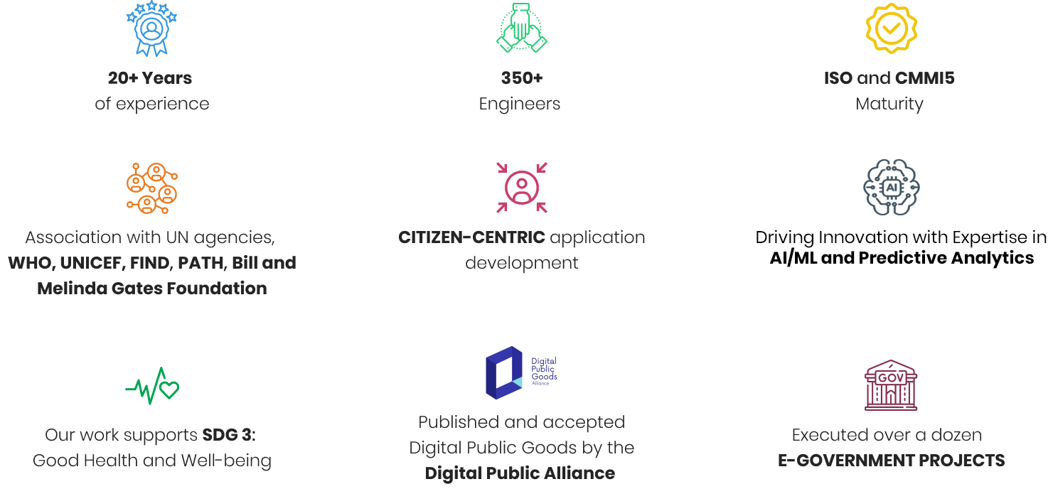
Argusoft brings over 25 years of experience delivering enterprise-scale digital transformation initiatives for governments, multilateral organizations and public-sector institutions worldwide. Supported by a team of 350+ technology professionals, we have partnered with organizations including the World Health Organization (WHO), UNICEF, PATH, the Bill & Melinda Gates Foundation, the Global Fund, Jhpiego, ODIHR, KPMG, Boston College, and national and state government agencies to design, develop, implement and support mission-critical digital platforms.
Our experience spans the complete lifecycle of enterprise information systems—from business analysis, solution architecture, and application development to system integration, cloud deployment, data migration, training, change management, and long-term operational support. We have successfully modernized legacy systems, digitized complex business processes, automated workflow-driven operations, and delivered configurable enterprise platforms supporting millions of users across healthcare, finance, procurement, customs, transport, housing, education, and regulatory sectors.
A key differentiator for Argusoft is our extensive experience delivering digital health platforms and National Health Information Systems. Over the past decade, we have designed and supported solutions covering disease surveillance, emergency preparedness, maternal and child health, immunization, HIV programmes, health financing, and public health programme management. These platforms have supported national governments, ministries of health, international organizations, and frontline healthcare workers in managing large-scale health programmes through configurable workflows, multidimensional data management, analytics, interoperability, and secure cloud-based architectures.
Our long-standing partnership with the World Health Organization provides us with a strong understanding of WHO's digital ecosystem, technical standards, governance processes, and collaborative implementation approach. Our experience includes the development and support of strategic WHO initiatives such as EWARS, JEE Reporting, EMS2, SimEx, Emergency Public Dashboard, P4H World, and Clinical Care in Crisis (EmCare). These engagements have involved complex workflow automation, configurable business rules, secure management of sensitive health information, interoperability with multiple systems, cloud deployments, and ongoing operational support across multiple countries and programmes.
In parallel, Argusoft has successfully implemented large-scale enterprise platforms for governments across multiple sectors. Our portfolio includes the License Management System for the Government of Jamaica, Trust and Estate Management System (TEMS), Data Visualization and Business Intelligence Platform (DVBI), Jamaica Customs Web & Auction Portal, Boston College EagleApps, and numerous workflow-driven digital transformation initiatives. These projects demonstrate our expertise in replacing legacy applications with modern, integrated platforms that streamline operations, strengthen governance, improve transparency, and support evidence-based decision-making.
For this assignment, our differentiator extends beyond technical capability. Having carefully reviewed the Terms of Reference, Functional Requirements, API Specifications, and clarifications, we understand that the success of the Health Accounts Data Management System depends not only on replacing the existing legacy application but on delivering a configurable, integrated, and sustainable solution that aligns with the existing xMart platform and supports the evolving needs of the Health Accounts programme. Our proposed approach emphasizes close collaboration with WHO, configuration over unnecessary customization, standards-based integration, robust quality assurance, structured knowledge transfer, and long-term maintainability.
Why Argusoft
- Proven WHO implementation experience, with successful delivery and long-term support of multiple mission-critical WHO digital platforms.
- Extensive experience in National Health Information Systems, supporting large-scale public health programmes, health data management, and evidence-based decision-making.
- Expertise in enterprise data management and configurable platforms, enabling rapid implementation while preserving flexibility for future enhancements.
- Strong integration capabilities, including API-driven interoperability, metadata management, validation of legacy-data transition interfaces, and secure cloud-based architectures.
- Hybrid Waterfall–Agile delivery methodology, combining structured planning with iterative development, continuous stakeholder engagement, and phased implementation.
- Commitment to sustainability, supported through comprehensive documentation, administrator and user training, knowledge transfer, warranty services, and long-term operational support.
By combining deep domain expertise in digital health, proven experience delivering enterprise platforms for WHO and governments, and a collaborative implementation approach, Argusoft is well positioned to deliver a secure, scalable, and sustainable Health Accounts Data Management System that aligns with WHO's technical, functional, and operational objectives.

Approach
Our approach to delivering the Health Accounts Data Management System (DMS) is centred on collaboration, configurability, and sustainability. We recognize that the success of this assignment depends not only on replacing the existing legacy application but also on delivering a solution that aligns with WHO's Health Accounts business processes, integrates seamlessly with the existing xMart platform, and supports the long-term evolution of the Health Accounts programme.
We will adopt a business-driven approach, working closely with the WHO Health Accounts team throughout the engagement to validate requirements, understand operational processes, and ensure that the solution reflects both current and future business needs. Continuous stakeholder engagement, regular demonstrations, and timely feedback will be integral to our approach, enabling progressive validation and reducing implementation risks.
Our approach emphasizes configuration over unnecessary customization, leveraging the capabilities of the existing xMart platform while extending it where required to meet the defined functional requirements. This ensures consistency with WHO's enterprise architecture, simplifies future maintenance, and provides flexibility to accommodate evolving Health Accounts processes without extensive redevelopment.
Quality will be embedded throughout the engagement rather than treated as a standalone activity. We will apply structured quality assurance, code reviews, testing, and validation practices to ensure that every deliverable meets WHO's functional, technical, and operational expectations before progressing to subsequent stages.
Recognizing the importance of Health Accounts data, our approach emphasizes data integrity, interoperability and business continuity. Argusoft will perform the required one-time migration of legacy Health Accounts data and formulas from the old DMS, including approximately 70,000 formulas currently stored in its Microsoft SQL Server database. The migration approach will cover extraction, transformation, loading into the agreed xMart/DMS target structures, formula metadata migration, required conversion into executable new-DMS formulas, reconciliation and WHO validation. Existing recurring pipelines from external systems into xMart are already in place and are not part of DMS development.
Finally, we view this assignment as a long-term partnership rather than a software implementation project. Alongside system delivery, we will focus on knowledge transfer, comprehensive documentation, administrator and user training, and collaborative engagement to enable WHO to effectively operate, maintain, and further evolve the Health Accounts Data Management System beyond the project duration.
Security & Coding Standards
Security and quality will be embedded throughout the development lifecycle to ensure the Health Accounts Data Management System aligns with WHO's technical and operational requirements. The solution will integrate with WHO Entra ID for secure Single Sign-On (SSO) authentication and role-based access control, ensuring users are authenticated and authorized in accordance with their assigned responsibilities.
Security will be treated as a core, cross-cutting deliverable throughout the solution lifecycle. Argusoft’s in-house cybersecurity team includes professionals holding industry-recognized certifications such as the Hack The Box Certified Penetration Testing Specialist (HTB CPTS), CompTIA Security+, and INE eLearnSecurity Junior Penetration Tester (eJPT). The security team will support architecture and threat reviews, security testing, vulnerability assessment, and remediation verification.
Argusoft will apply an OWASP-aligned secure software development lifecycle, including threat modelling during design, secure coding standards, peer code reviews, static application security testing, software composition analysis and dependency scanning, secret scanning, dynamic application security testing, and remediation of identified vulnerabilities before the Production release. The solution will enforce input validation, least-privilege access, country- and role-based authorization, secure API communication, comprehensive audit trails, centralized logging and monitoring, encryption in transit, and encryption at rest through WHO-approved Azure services and configurations.
As an organization, Argusoft maintains an ISO/IEC 27001 Information Security Management System (ISMS) and applies established quality management and software development practices across enterprise projects. These practices support the delivery of secure, maintainable, and scalable solutions while aligning with WHO's cloud-based architecture and security expectations.

Methodology
We recognize that the success of this assignment depends not only on the technology but also on the methodology adopted for execution. Considering the scope, stakeholder involvement, system integration, and phased implementation requirements, we propose a hybrid delivery approach combining both Waterfall and Agile methodologies.
During the initial phases of planning, requirements validation, and solution design, we will follow a Waterfall approach. This will enable detailed requirements finalization, process mapping, and development of interactive prototypes, ensuring all stakeholders have a clear and aligned understanding of the solution.
During the development phase, we will transition to an Agile methodology, executing the project in 2–4 week sprints. A prioritized backlog will be maintained, and incremental functionalities will be delivered with regular demonstrations and feedback cycles to ensure continuous alignment and improvement.
This hybrid approach ensures clarity in planning, flexibility in development, and timely delivery while effectively managing risks and stakeholder expectations throughout the project lifecycle. Each phase will include defined review and approval checkpoints with the WHO Health Accounts team to ensure alignment, validation, and controlled progression to subsequent stages.
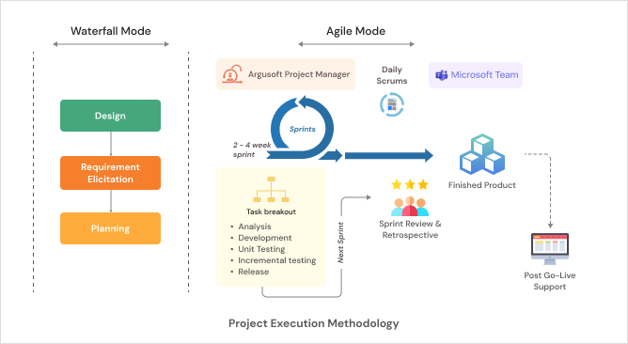

Proposed Solution

Proposed Work Plan
Our work plan is aligned with the implementation approach, milestones, and deliverables defined in the Terms of Reference. It follows a hybrid delivery model that combines structured planning with iterative Agile development, enabling continuous stakeholder engagement, phased delivery, and early validation throughout the project lifecycle. Each phase concludes with defined review and approval checkpoints to ensure quality, transparency, and controlled progression before moving to the next stage.
In parallel with the phase-wise activities described below, Argusoft will maintain key project management artefacts including the Project Management Plan, Sprint Backlog, Risk & Issue Register, Change Log, Quality Assurance Plan, and Project Status Reports. These artefacts will be reviewed and updated throughout the engagement to support effective project governance, communication, and progress monitoring.

Phase 1: Project Initiation & Requirements Gathering
Following contract signing, Argusoft will conduct a project kick-off meeting with the WHO Health Accounts team to establish project governance, communication mechanisms, timelines, and reporting arrangements. Detailed requirement gathering workshops will be conducted to validate functional and non-functional requirements, study the existing DMS, understand business processes for data import, analysis, verification, and publication, review xMart capabilities, API specifications, and legacy data structures, and confirm integration and migration requirements. The findings will form the foundation for solution design and implementation.
Deliverables
- Project Management Plan
- Technical Requirement Study
- Validated Functional & Technical Requirements
- Updated Implementation Work Plan

Phase 2: Solution Design & Prototype Development
Based on the validated requirements, Argusoft will prepare the technical and graphical design of the solution, including the overall architecture, DMS data model, integration design, security design, wireframes, UI/UX prototypes, deployment architecture and Azure cloud resource-sizing requirements. The proposed design will be presented to WHO for review and approval before development activities commence. Argusoft will establish and operate the Development environment using vendor-provided infrastructure, while WHO will provide and host the UAT and Production environments within WHO Azure.
Deliverables
- System Design Document
- Wireframes / UI-UX Prototypes
- Hardware Requirement Proposal
- Approved Technical & Graphical Design

Phase 3: System Development, Integration & Pilot Implementation
Development will be delivered through two-to-three-week Agile sprints, implementing the Pilot functionality first and then the remaining agreed requirements. The Pilot will include a general dashboard; advanced role-specific dashboards for administrators and regular users may be delivered under Priority 3. This phase includes the DMS application and APIs, bidirectional xMart integration, quality assurance, and UAT milestone deployments for WHO working-group functional acceptance. Argusoft will also perform the one-time migration of legacy Health Accounts data and approximately 70,000 legacy formulas from the old DMS, including loading formula metadata into xMart and conversion to the new DMS formula syntax as required by UC060. Existing external-source pipelines into xMart are already in place and are outside DMS development scope.

Deliverables
- Pilot DMS Functionalities
- Remaining Functional Modules
- Interim Demonstrations
- UAT Deployments
- Integrated and Tested System Components

Phase 4: System Testing & User Acceptance
Comprehensive testing will be conducted to verify that all system modules comply with the agreed functional requirements and acceptance criteria. This phase includes system testing, integration testing, performance testing, User Acceptance Testing (UAT), issue resolution, and final validation in collaboration with the WHO Health Accounts team before production deployment.
Deliverables
- Quality Assurance & Testing Reports
- User Acceptance Testing (UAT) Completion
- Final Demonstration
- Production Readiness Approval

Phase 5: Production Deployment, Training & Knowledge Transfer
Following successful UAT, the Health Accounts Data Management System will be deployed to the WHO Production environment. Administrator and user training will be conducted, followed by handover of all project artefacts, including technical documentation, database documentation, source code, system architecture documentation, user and administrator guides, and third-party licence keys (where applicable).
Deliverables
- Deployment of DMS on Production Server
- Training of Users and Administrators
- Training Report
- Database Technical Documentation
- Source Code & Technical Documentation
- System Architecture Documentation
- User & Administrator Guides
- Third-Party Licence Keys (if applicable)

Phase 6: Warranty, Cloud Infrastructure Support & Project Closure
Cloud infrastructure support and monitoring for UAT and Production will begin when the WHO-hosted environments are established and continue through implementation and the three-month warranty, which is included within the overall ten-month project period. Following Production deployment, Argusoft will provide 8x5 warranty support covering issue resolution, defect correction, Azure infrastructure assistance, monitoring, SSL-certificate monitoring, troubleshooting and Monthly Support & Maintenance Reports. Post-warranty support will be treated as a separate assignment.
Deliverables
- Warranty Services (3 Months)
- Monthly Support & Maintenance Reports
- Project Completion Report

Development Timeline

Quality Assurance Methodologies and Processes
Argusoft will apply a quality-first, risk-based assurance approach to ensure that the Health Accounts Data Management System (DMS) satisfies WHO’s functional, technical, integration, security, accessibility, migration and performance requirements. Quality assurance will be embedded throughout requirements validation, architecture and design, iterative development, integration, deployment and warranty support. Reviews, sprint demonstrations and formal validation checkpoints will provide progressive evidence that each contractual deliverable meets its approved acceptance criteria.

Test Strategy, Environments and Responsibilities
Argusoft will prepare a Master Test Plan covering test scope, approach, responsibilities, environments, test data, traceability, entry and exit criteria, defect management, reporting and acceptance evidence. Development-level, component and integration testing will be performed in the vendor-provided Development environment. Formal system verification and UAT will be conducted in the WHO-provided UAT environment using WHO-provided representative test data and xMart UAT access. As WHO has confirmed that no existing test cases or API regression suite are available, Argusoft will create the functional, integration, migration, formula-validation, security, performance and regression test assets required for the project.

Requirements Traceability and Acceptance
Argusoft will maintain a Requirements Traceability Matrix mapping each ToR objective and high-level requirement to the applicable use case, design component, sprint, test scenario and test case, UAT result, defect status and final acceptance status. This traceability will demonstrate coverage of all required use cases and support milestone-level acceptance.

The WHO working group will provide milestone and final acceptance based on applicable functional and operational test results. For each acceptance decision, Argusoft will submit the current traceability matrix, executed test evidence, defect status, migration and formula reconciliation results, security findings and remediation status, performance results, and a release-readiness or Test Completion Report.

Entry and Exit Criteria
Each test cycle will have documented entry and exit criteria. Entry criteria will include approved requirements and acceptance criteria, an available and stable test environment, a deployed test build, available interfaces, representative test data and completed developer testing. Exit criteria will include completion of planned tests, agreed requirements coverage, successful regression testing, resolution of all Critical and High-severity defects, documented disposition and WHO acceptance of any remaining lower-severity defects, and approval of the applicable Test Completion Report.

Defect Severity and Release Controls
Defects will be recorded, triaged, prioritized, assigned, corrected, re-tested and closed through a controlled issue-management workflow:
- Critical – system unavailability, security exposure, data corruption or failure of a critical process without a viable workaround; must be resolved before release.
- High – failure of a major function or business process without an acceptable workaround; must be resolved before release.
- Medium – impaired functionality for which a reasonable workaround exists; must be resolved or formally accepted for deferred correction.
- Low – minor usability, presentation or documentation issue; tracked and prioritized through the agreed backlog.
The final severity definitions, service expectations and approval authority will be confirmed during inception. No Production release will proceed with unresolved Critical or High-severity defects.

Functional, Workbook, Formula and Quality-Check Testing
Functional testing will verify all approved business processes and use cases, including users and roles, country-level access, configuration, classifications and crosses, metadata, workbooks, formulas, reports, versions, notifications, audit trails and administration. Workbook testing will include locking and concurrent read-only access, copy/paste, undo, filtering, import/export, formula/value handling, recalculation, version comparison and restoration.

Formula testing will verify syntax conversion, expected calculation results, rounding and precision, null and zero behaviour, divide-by-zero and invalid-reference handling, country/year/classification references, recalculation triggers, auditability and exception reporting. Quality Check module testing will cover predefined and customized rules, administrator and regular-user permissions, country/group applicability and exclusions, Passed/Failed/Error/Warning outcomes, manual workbook-triggered execution, Excel export and re-import of rule configuration, report generation and storage, and full year-end execution for approximately 196 countries. Retry, restart, progress visibility, job status and result consistency will also be verified against WHO-approved rules and representative expected results.

DMS–xMart Integration and API Testing
Argusoft will validate the bidirectional DMS–xMart interfaces, including API contracts, OAuth 2.0 authentication, HTTPS, CSV and optional JSON output, business-key and date-range filtering, internal identifiers, paging designed for the Annex 3 reference page size of 100,000 records, streaming, complete and incremental retrieval, range-filterable UTC LastModified values, inclusion or exclusion of soft-deleted records, update processing, error responses, retry behaviour and end-to-end data reconciliation. Existing external-source pipelines into xMart are outside the DMS development scope and will not be represented as direct DMS integrations.

Legacy Data, Metadata and Formula Migration Testing
Migration assurance will validate source-to-target mappings, record counts, mandatory fields, data types, referential integrity, duplicate handling, metadata associations, formula extraction and conversion, reconciliation totals, exception handling and audit evidence. Testing will cover the legacy data and approximately 70,000 formulas stored in the old DMS SQL Server, subject to the detailed migration and conversion rules agreed during discovery. Validation will use full-population checks where practical and WHO-approved sampling for fields or calculations requiring business review. A failed-conversion and reconciliation exception report will support correction and formal sign-off.

Performance, Reliability and Recovery Testing
During discovery, Argusoft and WHO will agree representative performance scenarios and measurable thresholds for interactive workbook operations, API calls, report generation, imports and exports, migration processing and year-end quality-check execution. Tests will cover workloads ranging from small selections to the stated 25-million-row maximum using server-side paging, streaming, asynchronous or background processing, or bulk extraction as appropriate; the design will not assume that all records are loaded interactively into a browser.

Performance and reliability testing will also cover approximately 20 concurrent internal users, the confirmed xMart batch capability, queue processing, progress visibility, restart and retry behaviour, failed-job recovery, notifications and sustained stability. Backup, restoration and recovery procedures will be tested against WHO-agreed recovery objectives before Production readiness.

Security, Accessibility and Compatibility Testing
Security assurance will be supported by Argusoft’s in-house cybersecurity team, including professionals holding certifications such as HTB CPTS, CompTIA Security+ and eJPT. Activities will include threat modelling, peer review, static application security testing, software-composition analysis, dependency and secret scanning, dynamic application security testing, authentication and authorization testing, API security testing, audit-log verification, input validation, country- and role-based access testing, and remediation verification before Production release. File-upload controls and malware scanning will be validated using the WHO-provided security scan API.

Accessibility testing will validate the applicable WHO accessibility requirements, keyboard navigation, focus order, labels, contrast and assistive-technology compatibility. Cross-browser and responsive testing will verify the supported user experience across the agreed browsers and viewport sizes.

Regression, UAT, Deployment and Warranty Verification
A maintainable regression suite will be established because no existing suite is available. Automated regression testing will be applied where cost-effective and sustainable, supplemented by manual testing for complex workflows and visual or exploratory scenarios. Argusoft will support WHO during UAT, triage and classify defects and agreed observations, implement in-scope corrections and minor modifications, and re-test resolved items.

Before Production deployment, Argusoft will complete the agreed regression, security, migration-reconciliation, performance, backup/restore and release-readiness checks. During warranty, the team will monitor solution quality, reproduce and resolve reported defects, verify corrections and maintain traceability to the affected requirement and release.

Quality Assurance Deliverables
The QA workstream will produce and maintain the following evidence:
- Master Test Plan and testing strategy.
- Requirements Traceability Matrix.
- Test scenarios, cases, scripts and representative test datasets.
- API contract, integration and DMS–xMart reconciliation report.
- Legacy data, metadata and formula migration reconciliation report.
- Performance, reliability and recovery test report.
- Accessibility and compatibility test report.
- Security testing and remediation report.
- UAT support, defect-closure and release-readiness report.
- Test Completion Report for each contractual milestone.
- Final consolidated testing and acceptance report.

This evidence-based assurance approach will provide WHO with transparent, measurable proof that the delivered DMS is functionally complete, secure, reliable, accessible, correctly integrated with xMart, accurately migrated and ready for sustainable operation by the WHO Health Accounts programme.

Capacity Building and Knowledge Transfer
Argusoft recognizes that the long-term success of the Health Accounts Data Management System (DMS) depends not only on successful implementation but also on WHO's ability to efficiently operate, administer, maintain, and further enhance the platform. Our capacity-building approach is therefore designed to equip both system administrators and business users with the knowledge and practical skills required to effectively use and manage the solution.
Knowledge transfer will be embedded throughout the implementation lifecycle through continuous collaboration, solution demonstrations, validation sessions, and hands-on engagement with the WHO Health Accounts team. This progressive approach enables users to become familiar with the system as it evolves, facilitating smoother adoption and reducing the learning curve during deployment.
Key Capacity Building Activities
Administrator & User Training
Argusoft will conduct comprehensive training sessions for the system administrators and designated WHO users covering system functionality, administration, configuration, user management, reporting, troubleshooting, and routine operational activities. Training will be delivered remotely in English for the designated participants in accordance with the project requirements.
Technical Documentation
Comprehensive technical documentation will be provided to support long-term system maintenance and future enhancements. This will include system architecture documentation, database technical documentation, source code documentation, deployment information, and configuration details required for ongoing system administration.
User & Administrator Guides
Role-based User and Administrator Guides will be prepared to support day-to-day system operation and administration. The guides will include operational procedures, module-wise instructions, configuration guidance, and troubleshooting information to assist users in effectively utilizing the platform.
Knowledge Transfer & Handover
Upon successful completion of the project, Argusoft will hand over the complete source code, technical documentation, database documentation, system architecture documentation, user and administrator guides, and other project artefacts to WHO, ensuring full ownership and the ability to independently maintain and further enhance the solution.

Support, Maintenance & Warranty Services
Argusoft is committed to ensuring the continued stability, availability, and performance of the Health Accounts Data Management System beyond its initial deployment. Our support approach is aligned with the Terms of Reference and is designed to provide timely issue resolution, proactive infrastructure monitoring, and continuous operational support throughout the warranty period.
Following Production deployment, Argusoft will provide a three-month warranty covering all modules of the DMS. During this period, reported defects, functionality issues, agreed feature enhancements, customizations, and additional reports within the defined project scope will be addressed promptly to ensure uninterrupted system operation. In accordance with the Terms of Reference, modifications requiring up to 10 working days by one resource will be treated as part of the project scope, while larger enhancements will be jointly assessed and prioritized with WHO. Up to 20% scope adjustments during development and warranty will be accommodated as specified in the ToR.
In parallel, Argusoft will provide cloud infrastructure support for both the User Acceptance Testing (UAT) and Production environments. Activities will include infrastructure configuration and maintenance, 24/7 automated monitoring of server performance and availability, Azure infrastructure administration, SSL certificate monitoring, troubleshooting, configuration updates, and coordination with Microsoft where required to resolve cloud-related issues. Monthly Support & Maintenance Reports will be submitted to WHO summarizing activities performed, infrastructure changes, issues resolved, and overall system health.
Our support services will leverage Argusoft's extensive experience in providing long-term maintenance and operational support for enterprise platforms, including multiple WHO digital health systems, ensuring that the Health Accounts Data Management System remains secure, stable, and fully operational throughout the support period.

Key Personnel

Key Experts
Name | Role | Experience | Profile Summary
Mayank Modi | Project Manager | 15+ years | Expert in leading large-scale enterprise information systems for WHO, UN agencies, governments, and international organizations. Extensive experience managing complex data management and digital transformation projects using Agile and Waterfall methodologies. Strong expertise in project governance, stakeholder engagement, risk management, quality assurance, reporting, user training, and successful delivery of multi-disciplinary teams. Experienced in business process transformation, design thinking, and fixed-price enterprise implementations.
Yashvi Pomal | Lead Business Analyst | 5+ years | Expertise in business analysis, requirements engineering, and enterprise data management platforms. Experienced in documenting As-Is and To-Be business processes, BPMN modelling, workflow analysis, functional specifications, user stories, acceptance criteria, and analytical reports. Strong background in stakeholder workshops, cross-functional process analysis, data management systems, user training, and supporting Agile delivery for WHO and government digital transformation initiatives.
Karan Patel | Technical Lead | 9+ years | Expert in designing and leading the development of enterprise data management platforms using Microsoft .NET, C#, ASP.NET, Angular, SQL Server, Azure, and REST APIs. Extensive experience in solution architecture, system integration, secure data collection and standardization, advanced analytics, database design, microservices, and enterprise application customization. Proven track record leading development teams through architecture, deployment, training, handover, and cloud-based implementations, with experience in Azure, containerization, and Microsoft technologies.
Vishal Godhani | Senior Software Engineer | 7+ years | Extensive experience developing enterprise web applications using .NET, C#, ASP.NET, Angular, JavaScript, HTML5, CSS3, SQL Server, and RESTful APIs. Skilled in designing scalable system architectures, database design, microservices, workflow-driven applications, system optimization, and enterprise integrations. Strong expertise in responsive UI development, API integration, performance optimization, and implementing secure, maintainable solutions for WHO and large public sector platforms.
Janmajay Jani | Data Analyst | 9+ years | Expert in data modelling, database design, ETL processes, statistical analysis, and enterprise reporting. Extensive experience working with SQL, Business Intelligence tools, Excel, SPSS, SAS/R, XML, and data quality management. Skilled in analysing complex datasets, designing data validation and quality rules, reporting and dashboard development, metadata management, and optimizing large-scale data management systems. Experience supporting health information systems, expenditure data analysis, and evidence-based decision-making is a strong asset.
Niraj Lathiya | DevOps / Cloud Infrastructure Engineer | 7+ years | Expert in Azure cloud architecture, CI/CD, Infrastructure as Code (Terraform), Azure DevOps, GitLab CI/CD, Docker, Kubernetes (AKS), Azure Functions, API Management, IIS, SQL PaaS, Storage Accounts, monitoring, security, and automation. Extensive experience deploying and maintaining enterprise applications on Microsoft Azure, implementing DevOps pipelines, monitoring cloud environments, troubleshooting deployments, managing SSL certificates, and ensuring secure, reliable, and scalable digital operations.
Manoj V. John | Product Designer (UI/UX) | 20+ years | Expert in user-centred design for enterprise data management platforms, dashboards, and workflow-driven applications. Extensive experience in information architecture, wireframing, prototyping (Figma), usability testing, accessibility, responsive design, and data visualization. Skilled in translating complex business processes into intuitive user experiences and collaborating closely with business users, developers, and policy teams to improve usability, accessibility, and user adoption across public sector and WHO projects.

Non Key Experts

Role | Experience | Profile Summary
Software Quality Assurance (QA) Specialist | 9+ years | Expert in quality assurance for enterprise web applications and data management systems. Extensive experience in test planning, functional, integration, regression, performance, security, and User Acceptance Testing (UAT). Skilled in API testing, automation frameworks, defect management, quality reporting, and validating workflow-driven and data-intensive applications to ensure compliance with functional requirements and acceptance criteria.
Database Engineer | 7+ years | Expert in database architecture, SQL Server, PostgreSQL, MySQL, performance tuning, data migration, ETL processes, metadata management, backup and recovery, and database optimization for enterprise data management systems.
Technical Writer/ Trainer | 5+ years | Experienced in preparing technical documentation, user manuals, administrator guides, training materials, and conducting remote user and administrator training sessions for enterprise information systems and digital platforms.

The proposed team structure ensures optimal allocation of expertise across all project phases, with clearly defined responsibilities and active involvement throughout the lifecycle to ensure continuity, quality, and accountability in delivery.

Resumes of Key Resources

Mayank Modi - Project Manager (PMP Certified)
Experience: 17+ Years
Proposed Role: Project Manager
Professional Summary
- Mayank Modi is a seasoned Project Manager with 17+ years of experience leading large-scale software development projects, enterprise information systems, digital health platforms, and data analytics solutions across government and international clients.
- He holds a Master of Computer Applications (MCA) and is a Project Management Professional (PMP) with extensive experience managing projects across the complete lifecycle, including requirements gathering, scope definition, solution design, development, UAT, deployment, stakeholder management, risk management, quality assurance, training, and operational handover.
- Mayank has managed complex public-sector and international projects including TIMS for eGov Jamaica and the Ministry of National Security Jamaica, eKavach for the Government of Uttar Pradesh, TEMS for the Administrative General's Department Jamaica, SOFY Data Analytics Platform for KPMG Netherlands, and MedPlat (TeCHO+) for the Government of Gujarat.
- He has led multidisciplinary teams of 20+ resources, coordinating developers, QA, DevOps, UI/UX and Business Analysis teams, while managing stakeholder requirements, project scope, resources, risks, milestones, quality and delivery. His experience includes Agile and Waterfall methodologies, stakeholder engagement, project governance, solution design coordination, UAT, production deployment, user training and Train-the-Trainer activities.
Core Competencies
- Project & Program Delivery Management
- Enterprise Information Systems
- Digital Health & Public Health Platforms
- Data Analytics & Data-driven Solutions
- Government Stakeholder Coordination
- Requirements Gathering & Scope Management
- Agile & Waterfall Methodologies
- Sprint & Milestone Planning
- Cross-functional Team Leadership
- Resource Planning & Management
- Risk, Issue & Dependency Management
- Quality Assurance & UAT Management
- Production Deployment & Go-Live
- Stakeholder Reporting & Governance
- User Training & Train-the-Trainer
- Business Process Transformation
- Solution Design Coordination
- Change Management & Operational Handover
Technical Skills
- Languages: Python, Java/J2EE, NodeJS
- Front-end & Web: Angular, Vue, Bootstrap
- Project Management: Agile, Waterfall, Sprint Planning, Risk Management, Resource Management, Scope Management, UAT
- Architecture & Design: Enterprise Information Systems, High-level & Detailed System Design, Block Diagrams, Class Diagrams, Modular Solutions
- Domain Expertise: Digital Health, Public Health, Data Analytics, Government Information Systems, Data-driven Platforms
- Development Practices: Software Development Lifecycle, Quality Assurance, Stakeholder Reviews, Production Deployment, Technical Coordination
Professional Certifications
- Project Management Professional (PMP) – Credential #2908385, December 2020
Sun Certified Professional – 2009
Qualification
- Master of Computer Applications (MCA)
Gujarat University, India
- Bachelor of Computer Applications (BCA)
South Gujarat University, India
Relevant Project Experience
1. TIMS (Ticket Information Management System) — eGov Jamaica / Ministry of National Security Jamaica
Role: Project Manager
Period: 2023 – Present
Project Description
TIMS is a web-based application developed for the Ministry of National Security to streamline the management of traffic tickets from issuance through resolution. The system integrates with critical systems including SmartCheck, TTIS and INCRS and supports multiple services and entities involved in the Ministry's operations.
Key Responsibilities
- Spearheaded the project in close collaboration with eGov Jamaica and the Ministry of National Security to address diverse stakeholder requirements and ensure seamless integration with existing systems.
- Led regular stakeholder meetings to communicate project status, address challenges and review risk mitigation plans.
- Implemented Agile methodologies, including sprint planning, daily stand-ups and retrospective meetings in coordination with the Scrum Manager.
- Coordinated cross-functional teams comprising developers, QA, DevOps and UI/UX resources.
- Managed project scope, resource planning and allocation, milestones and delivery activities.
- Identified project risks and implemented mitigation and contingency plans throughout the project lifecycle.
- Ensured delivery within agreed timelines and budget while maintaining quality and stakeholder alignment.
2. eKavach — Government of Uttar Pradesh, India
Role: Project Manager
Period: 2021 – 2023
Project Description
eKavach is a comprehensive public health platform implemented using MEDplat for the Health Ministry of Uttar Pradesh. The platform supports more than 250,000 field health workers serving a population of more than 250 million, covering services including family planning, pregnancy tracking, identification of high-risk pregnant women, treatment counselling and immunization tracking.
Key Responsibilities
- Led a large team of 20+ resources and participated in understanding public health challenges, defining user-centric digital solutions and overseeing application development and deployment.
- Conducted consultations with field workers, healthcare professionals and government officials to capture requirements and inform the platform development strategy.
- Managed the project lifecycle from inception through go-live.
- Directed Business Analysts in requirements analysis, gap identification and estimation of required customizations.
- Guided prototype and solution design and secured approval from government stakeholders.
- Led the Train-the-Trainer programme supporting the adoption of the platform by more than 250,000 healthcare workers.
- Coordinated application registration and multi-level review through the DPG process, culminating in the product being listed as a Digital Public Good under SDG 3.
- Coordinated integration with the Government of Uttar Pradesh State FAMS to support bulk disbursement of Performance-Based Incentives and Team-Based Incentives.
3. TEMS (Trust & Estate Management System) — Administrative General's Department, Jamaica
Role: Project Manager
Period: 2017 – 2020
Project Description
TEMS is an enterprise information system developed for the Administrative General's Department of Jamaica, requiring requirements analysis, system design, development, stakeholder coordination and user acceptance.
Key Responsibilities
- Led client communications for requirements gathering and scope definition.
- Guided the technical team in developing high-level and detailed system designs, including block diagrams and class diagrams.
- Addressed potential system challenges and implemented adjustments to support scalability and sustainability.
- Directed resource planning and management and aligned team activities with project milestones.
- Maintained regular engagement with clients and stakeholders through solution progress reviews.
- Managed the User Acceptance Testing (UAT) process and coordinated the development team and client stakeholders to refine and approve the solution.
4. SOFY – Data Analytics Platform — KPMG, Netherlands
Role: Project Manager
Period: 2014 – 2020
Project Description
SOFY is a data analytics platform developed for KPMG Netherlands, involving customization of the platform to meet business requirements and transformation of complex datasets into actionable insights.
Key Responsibilities
- Directed development activities and ensured alignment with KPMG's product vision.
- Worked closely with KPMG Product Owners to understand business requirements and customize the platform accordingly.
- Initiated requirements identification and engaged stakeholders across multiple domains to understand and document business processes.
- Led resource planning and management and established project scope and milestones with the team.
- Maintained continuous communication with clients and stakeholders through solution progress reviews and feedback cycles.
- Participated in onsite discussions and support activities in the Netherlands.
5. MedPlat (TeCHO+) — Government of Gujarat, India
Role: Project Manager
Period: 2014 – 2017
Project Description
MedPlat (TeCHO+) is a digital health platform supporting public health programmes and frontline health workers across Gujarat, requiring extensive stakeholder engagement, requirements gathering, Agile delivery, system development, quality assurance and government coordination.
Key Responsibilities
- Led requirements gathering with field workers, healthcare professionals and government officials.
- Worked closely with Business Analysts to develop Work Breakdown Structures and allocate tasks to team members.
- Managed the project using Agile methodology.
- Monitored project progress and communicated updates to government stakeholders.
- Maintained the project Risk Register and coordinated mitigation of identified risks.
- Reviewed QA reports and error logs and coordinated appropriate resolution activities.
- Facilitated collaboration across developers, QA, DevOps and UI/UX teams.
- Coordinated with government agencies to align project objectives with digital health strategies.
- Managed stakeholder expectations and maintained transparent communication throughout project execution.
- Conducted training sessions and workshops for government officials and healthcare professionals to support adoption and effective use of the platform.

Yashvi Pomal - Lead Business Analyst
Experience: 5+ Years
Proposed Role: Key Expert 2 – Business Analyst / Group Lead
Professional Summary
- Yashvi Pomal is an IT professional with 5+ years of experience in business analysis, project coordination, and Agile delivery of large-scale mobile, web, and desktop applications, with significant experience in the public health domain.
- She has demonstrated experience working with government clients, international organizations, and cross-functional technical teams, translating business needs into actionable requirements, functional specifications, prototypes, and successful product outcomes.
- Yashvi has experience across the end-to-end project lifecycle, including requirements elicitation and analysis, functional and technical documentation, Agile/Scrum delivery, sprint planning, stakeholder coordination, UAT support, defect tracking, risk identification, task prioritization, and release management.
- Her experience includes key public health and health information system projects such as MEDPlat – TeCHO+ for the Government of Gujarat, eKavach for the Government of Uttar Pradesh, and EWARS for the World Health Organization, providing strong exposure to health-data workflows, government programmes, field-level operations, and internationally deployed health information systems.
- She is experienced in facilitating communication between business stakeholders, development and testing teams, supporting requirements validation, resolving operational issues, and ensuring that delivered solutions remain aligned with business requirements, scope, quality expectations, and stakeholder needs.
- Yashvi is a Certified Scrum Master with strong capabilities in Agile and Scrum-based project delivery, stakeholder and client management, requirements documentation, risk identification and mitigation, UAT planning and execution, decision making, strategic planning, communication, and team facilitation.
Core Competencies
- Business Analysis & Requirements Engineering
- Requirements Elicitation & Documentation
- Business Needs Analysis
- Functional & Technical Documentation
- Agile & Scrum Delivery
- Stakeholder & Client Management
- Government & Public Health Projects
- Project Coordination & Delivery Tracking
- Sprint Planning & Task Prioritization
- User Acceptance Testing (UAT)
- Functional Analysis & Enhancement Management
- Risk Identification & Mitigation
- Defect Tracking & Resolution Coordination
- Interactive Prototyping
- Release Management
- Cross-functional Team Facilitation
- Product Adoption & Implementation Support
- Process Documentation & User Guides
Professional Skill Set
Certification:
- Certified Scrum Product Owner (CSPO)
- Certified Scrum Master (CSM)
- Scrum Fundamentals Certified (SFC)
Project Management: Agile & Scrum-based Project Management, Sprint Planning, Task Prioritization, Delivery Tracking, Release Management
Business Analysis: Requirements Elicitation, Requirements Analysis, Functional Documentation, Enhancement Analysis, Business Needs Assessment, Interactive Prototyping
Stakeholder Management: Government Client Coordination, International Organization Coordination, Stakeholder Communication, Client Feedback Management
Quality & Delivery: UAT Planning & Execution, Defect Tracking, Issue Resolution, Risk Identification & Mitigation, Product Release Coordination
Documentation: Functional & Technical Documentation, User Guides, Administrator Guides, Developer Documentation, Project Resource Documentation
Languages: English, Hindi, Gujarati
Qualification
Bachelor of Computer Engineering
Marwadi University, India
Masters of Business Administration
DY Patil Institute of Distance Learning

Relevant Project Experience
1. MEDPlat – TeCHO+ Implementation — Government of Gujarat
Role: Senior Business Analyst
Year: 2021
Location: Gandhinagar, Gujarat
Project Description
MEDPlat – TeCHO+ is a statewide, name-based digital health platform supporting Family Health Surveys, Reproductive and Child Health (RCH) programmes, LMP tracking, and maternal and child health monitoring. The system enables real-time data collection and reporting across multiple levels of health administration.
Key Responsibilities
- Led day-to-day project coordination and supported the effective adoption of Agile methodology across the project team.
- Managed and maintained comprehensive functional and technical documentation throughout the project lifecycle.
- Conducted requirements gathering and enhancement analysis for mobile applications based on business and user needs.
- Reviewed existing system functionality and identified enhancements required to align the solution with evolving business requirements.
- Coordinated bug tracking and resolution with development teams and supported timely closure of functional issues.
- Coordinated and supported User Acceptance Testing (UAT) activities with relevant stakeholders.
- Supported successful product releases and ensured delivered functionality remained aligned with agreed scope, quality standards, and stakeholder expectations.
2. eKavach — Government of Uttar Pradesh
Role: Senior Business Analyst
Year: 2020
Location: Gandhinagar, Gujarat
Project Description
eKavach is a comprehensive public health platform implemented under the National Health Mission, Uttar Pradesh, supporting 200,000+ health workers and more than 1 million beneficiaries across immunization, nutrition, and disease monitoring programmes.
Key Responsibilities
- Coordinated Agile execution and supported sprint-level planning and delivery activities.
- Defined requirements for new user roles and functional modules based on programme and stakeholder requirements.
- Prepared detailed requirement documents and interactive prototypes to communicate proposed functionality to technical and business stakeholders.
- Tracked tasks and project progress using GitLab and coordinated activities across development and testing teams.
- Supported rapid identification and resolution of ground-level operational issues affecting users and field operations.
- Acted as a bridge between development, testing, and client stakeholders to ensure requirements and issues were clearly communicated and addressed.
- Supported finalization, validation and rollout of new features and enhancements.
3. EWARS (Early Warning, Alert and Response System) — World Health Organization
Role: Business Analyst
Year: 2020
Location: Gandhinagar, Gujarat
Project Description
EWARS is a World Health Organization initiative supporting disease surveillance and outbreak response in humanitarian emergencies through a field-based, real-time information system.
Key Responsibilities
- Maintained and updated project resource repositories and supporting project documentation.
- Authored comprehensive system documentation, including the EWARS Web User Guide, EWARS Mobile User Guide, IT Administrator Installation Guide, and Developer Guide covering system architecture and modules.
- Collaborated regularly with WHO stakeholders to gather feedback, clarify requirements, and maintain alignment with project objectives.
- Coordinated defect tracking and follow-up activities with technical teams to support timely resolution.
- Supported delivery of a well-documented and globally deployable health information solution.
- Contributed to knowledge transfer and documentation required for effective system adoption, administration, and continued technical use.

Karan Patel - Tech Lead / Technical Lead
Experience: 10+ Years
Proposed Role: Key Expert 3 – Technical Lead
Professional Summary
- Karan Patel is a seasoned technology professional with 10+ years of experience in designing, developing, and technically leading enterprise-scale information systems and data-driven applications. He holds a Master of Engineering in Computer Engineering and a Bachelor of Engineering in Information Technology.
- He has extensive experience in .NET Core, ASP.NET, Web API, SQL Server, Azure Cloud Services, ETL, data cleansing, data integration, data migration, data harmonization and data warehousing, with strong expertise in developing scalable, secure and high-performance backend solutions.
- Karan has served as Technical Lead/Team Lead on multiple complex projects for WHO, the Government of Zambia, and international clients, including Emergency Dashboard for WHO, CHiP – Community Health Information Platform for the Government of Zambia, JEE Reporting for WHO, and Ignite ETRM. His experience includes leading development teams, designing system architectures, implementing backend and integration layers, managing deployment, conducting code reviews, supporting cybersecurity assessments, and coordinating UAT and production rollouts.
- He has strong experience in secure data collection, standardization, integration and exchange across multiple systems, including integration with xMart, DHIS2 and other national systems. His data-management experience includes ETL, data cleansing, integration, migration, harmonization and warehousing.
- Karan has demonstrated technical leadership in Agile environments through sprint planning, technical team coordination, code reviews, DevOps activities, deployment management, troubleshooting and production support. He has worked closely with government, WHO, PATH, infrastructure and cybersecurity teams to understand customer needs, align technical solutions with requirements, and ensure secure and successful deployment.
- His technical expertise spans C#, .NET Framework, .NET Core, ASP.NET MVC, Web API, ASP.NET WebForms, Azure Functions, JavaScript, TypeScript, Angular, SQL Server, Entity Framework, RabbitMQ, SignalR, OAuth 2, OData and Azure Cloud Services, with experience in application architecture, data integration, performance optimization, cybersecurity compliance and scalable system development.
Core Competencies
- Technical Leadership & Team Management
- Enterprise Information Systems
- Data Management Platforms
- System Architecture & Solution Design
- Backend Development & API Development
- Data Collection, Integration & Standardization
- ETL, Data Migration & Data Harmonization
- Data Warehousing
- Azure Cloud Services
- .NET & Microsoft Technology Stack
- Microservices & Modular Architecture
- Secure API & Data Exchange
- DHIS2 & xMart Integration
- Agile/Scrum Development
- Sprint Planning & Code Reviews
- DevOps & Deployment Management
- Cybersecurity & Vulnerability Management
- Performance Optimization
- UAT, Deployment & Production Rollout
- Technical Troubleshooting & Problem Solving
- Stakeholder & Customer Coordination
Technical Skills
- Languages: C#, SQL, JavaScript, TypeScript
- Frameworks: .NET Framework, .NET Core, ASP.NET MVC, ASP.NET WebForms, Entity Framework
- Back-End Technologies: ASP.NET Web API, Azure Functions, OData, RabbitMQ, SignalR, NRules, Task Schedulers
- Front-End Technologies: Angular 11, JavaScript, TypeScript, jQuery, Bootstrap, CSS3, HTML5, Knockout.js, Highcharts.js, Leaflet, ArcGIS Maps
- Application Servers: IIS 7.0, IIS 8.0
- Databases: Microsoft SQL Server
- Data Management: ETL, Data Cleansing, Data Integration, Data Migration, Data Harmonization, Data Warehousing
- Cloud Services: Microsoft Azure Cloud Services
- Security & Integration: OAuth 2, Secure APIs, Data Exchange Protocols, Cybersecurity Assessments, Vulnerability Management
- Tools: Visual Studio, Visual Studio Code, SQL Server Management Studio, Azure Data Studio
- Third-Party APIs: ICE FIX API, CME FIX API, Bloomberg Data License API, Vessel Finder API and travel booking APIs
Qualification
Master of Engineering – Computer Engineering
BVM Engineering College, V.V. Nagar, Gujarat, India | 2013–2015
Bachelor of Engineering – Information Technology
GEC Sector-28, Gandhinagar, Gujarat, India | 2009–2013
Relevant Project Experience
1. Emergency Dashboard — World Health Organization (WHO)
Role: Team Lead
Period: 2022 – Present
Project Description
Emergency Dashboard is a WHO Health Emergencies Programme platform enabling real-time visualization of outbreak data and health indicators from multiple systems.
Key Responsibilities
- Led end-to-end development and system integration with the xMart data platform.
- Provided technical leadership for backend development, system integration and data retrieval components.
- Managed backend performance and optimized data retrieval for visualization and dashboard requirements.
- Oversaw cloud deployment and cybersecurity compliance in accordance with WHO policies.
- Collaborated with WHO infrastructure teams to coordinate production releases and deployment activities.
- Conducted refactoring and modernization of legacy code components to improve maintainability and performance.
- Supported troubleshooting and resolution of technical issues affecting application performance and production operations.
2. CHiP – Community Health Information Platform — Government of Zambia
Role: Technical Lead
Period: 2020 – 2022
Project Description
CHiP is a community health information platform supporting real-time data collection, monitoring and reporting across multiple districts in Zambia. The platform integrates mobile and web interfaces with national health repositories and was implemented in collaboration with the Ministry of Health and PATH.
Key Responsibilities
- Led backend and integration components and ensured development of a scalable and modular system architecture.
- Worked closely with PATH's technical team and the Ministry of Health's IT team for requirements alignment, technical discussions and testing.
- Collaborated with the Government of Zambia's cybersecurity team to complete vulnerability assessments and achieve security clearance for go-live.
- Implemented secure APIs and data exchange protocols for integration with DHIS2 and other national systems.
- Directed sprint planning, technical coordination and code reviews to maintain development quality.
- Led DevOps activities and supported deployment, rollout and operational continuity.
- Troubleshot technical issues and coordinated resolution across development and integration components.
3. JEE Reporting — World Health Organization (WHO)
Role: Team Lead
Period: 2018 – 2020
Project Description
JEE Reporting is a WHO platform supporting Joint External Evaluation (JEE) missions for assessment of national public health preparedness.
Key Responsibilities
- Provided technical leadership across backend and frontend development teams.
- Designed and implemented system architecture using .NET Core and Angular.
- Managed deployment pipelines and Azure-based hosting in alignment with WHO security standards.
- Coordinated with WHO's IMT and cybersecurity units to address technical and security requirements.
- Led User Acceptance Testing and production rollout across multiple regions.
- Coordinated technical teams throughout development, deployment and production implementation.
4. Ignite ETRM — Energy Trading and Risk Management Platform
Role: Team Lead
Period: 2016 – 2018
Project Description
Ignite ETRM is a cloud-based Energy Trading and Risk Management system supporting front, middle and back-office operations.
Key Responsibilities
- Led the backend development team implementing event-driven microservices and data pipelines.
- Designed scalable services supporting trade, pricing and logistics modules.
- Integrated third-party APIs including ICE and CME for real-time market data exchange.
- Applied DevSecOps and CI/CD principles to support automated software releases.
- Led performance optimization activities and supported system resilience and scalability.
- Provided technical guidance to the development team on architecture and implementation.
5. Musterkunde — Germany
Role: Senior Software Developer
Period: 2015 – 2016
Project Description
Musterkunde is a CRM and analytics solution for German banks supporting customer profiling and predictive insights.
Key Responsibilities
- Developed backend modules using .NET Core and Entity Framework Core.
- Implemented ETL data flows and statistical reporting using SSIS/SSRS.
- Designed OData endpoints for analytics integration.
- Supported frontend development teams through API and data model design.
- Contributed to database and data-processing activities supporting analytics requirements.

Janmejay Jani - Data Analyst
Experience: 8+ Years
Proposed Role: Key Expert 5 – Data Analyst
Professional Summary
- Janmejay Jani is an experienced technology professional with 8+ years of experience in data science, data analysis, full-stack development, machine learning, and AI-driven solutions, with significant experience working with large datasets and public health information systems.
- He holds a Bachelor of Engineering in Computer Science and a PG Programme in Deep Learning – Foundations and Applications from the Indian Institute of Science, Bangalore. His technical background combines data analysis, data engineering, software development, database management, statistical modelling, machine learning, and AI.
- Janmejay has worked on data-intensive platforms including TeCHO+ and MEDPlat, where he has developed data pipelines, reporting systems, dashboards, data-processing algorithms, classification, clustering and prediction models, and AI-based analytical solutions for public health data.
- His experience includes collecting, cleaning, transforming, standardizing and validating large datasets, developing data models and pipelines, performing geospatial analysis, generating health indicators, and developing reporting and visualization solutions to support evidence-based decision-making.
- He has strong experience with Python, SQL, Pandas, NumPy, PyTorch, TensorFlow, scikit-learn, Matplotlib, Plotly and databases including PostgreSQL, MySQL, Oracle, SQL Server, MongoDB and Cassandra. He also has experience with ETL/data migration, data integration and full-stack technologies, enabling him to work across the complete data lifecycle.
- Janmejay has applied machine learning and statistical techniques including classification, clustering, prediction, NLP, text analytics, transformer-based modelling and data segmentation to identify patterns and generate insights from structured and unstructured datasets.
- His public health experience includes developing reporting and analytics capabilities for TeCHO+ and MEDPlat, including geospatial analysis of health indicators, real-time dashboards, continuous data collection and integration, automated data analysis, text analytics, and classification of healthcare-related information.
Core Competencies
- Data Analysis & Data Science
- Data Modelling & Database Design
- Data Collection, Cleaning & Transformation
- Data Mining & Segmentation
- Data Integration & ETL
- Data Validation & Standardization
- Statistical & Predictive Analysis
- Classification, Clustering & Prediction
- Healthcare Data Analytics
- Geospatial Data Analysis
- Data Pipelines & Data Processing
- Reporting & Dashboard Development
- Data Visualization
- Machine Learning & Deep Learning
- Natural Language Processing
- Text Analytics
- AI-based Data Analysis
- Large Dataset Management
- Data Quality & Validation
- Analytical Problem Solving
Technical Skills
- Programming Languages: Python, Java, JavaScript, TypeScript, SQL, Node
- Data Science & Machine Learning: PyTorch, TensorFlow, scikit-learn, NumPy, Pandas, Matplotlib, Plotly, LLMs, Transformers, LSTM, GRU, CNN, GANs, Autoencoders
- Data Analysis: Classification, Clustering, Prediction, Data Mining, Data Transformation, Data Cleaning, Data Validation, Geospatial Analysis, Text Analytics, Statistical Analysis
- Databases: PostgreSQL, Oracle, MySQL, SQL Server, MongoDB, Cassandra
- Data Engineering: Data Pipelines, ETL, Data Integration, Data Migration, Data Standardization, Data Transformation
- Reporting & Visualization: Real-time Dashboards, Reporting Systems, Plotly, Matplotlib, Grafana
- Frameworks & Technologies: Spring, Spring Boot, Hibernate, ExpressJS, NodeJS, Angular, Flask, Streamlit
- Tools: JIRA, Trello, GitLab, Git, Maven, Bamboo
- Cloud Technologies: Microsoft Azure, AWS
Qualifications
- Bachelor of Engineering in Computer Science
Government Engineering College, Gandhinagar
Professional Certification
- PG Programme in Deep Learning – Foundations and Applications
Indian Institute of Science, Bangalore
Languages: English, Hindi, Gujarati
Relevant Project Experience
1. TeCHO+ — Digital Public Health Platform
Role: Group Lead – Technology / Data & AI
Environment & Tools: Python, PyTorch, Plotly, Angular 12, Spring Boot, PostgreSQL, SonarQube, Git
Project Description
TeCHO+ is a configurable mHealth framework built on the MEDPlat platform, supporting Family Health Surveys, Reproductive & Child Health (RCH) programmes, LMP tracking, maternal and child health monitoring, and real-time health-data collection and reporting.
Key Responsibilities
- Developed a reporting system that processes collected health data and performs geospatial analysis to generate insights into health indicators based on geographical location.
- Developed algorithms for classification, clustering and prediction of required data fields.
- Worked on AI-based functionalities to support data-driven strategies and improve user engagement.
- Designed and developed reliable and maintainable data-processing and analytical solutions.
- Worked on making TeCHO+ interoperable using established standards and patterns.
- Contributed to core architectural and business logic supporting data processing and analytics.
- Collaborated with Business Analysts and Testing teams to validate analytical functionality and ensure alignment with requirements.
2. MEDPlat – Low Code Public Healthcare Platform
Role: Data Scientist
Environment & Tools: Python, PyTorch, Plotly, Angular, Tailwind, NumPy, Pandas, MongoDB, Git
Project Description
MEDPlat is a configurable low-code public healthcare platform designed to support healthcare management and monitoring across multiple geographies. The platform enables field workers to deliver healthcare services through mobile applications while providing stakeholders with web-based, real-time insights into service delivery.
Key Responsibilities
- Developed and maintained data pipelines supporting continuous data collection and integration.
- Developed real-time dashboards and reporting tools for healthcare stakeholders.
- Applied machine learning models to automate routine data analysis and identify patterns in healthcare datasets.
- Developed multilingual chatbots to support field workers and stakeholders in accessing information from the platform.
- Implemented text analytics to extract insights from unstructured sources including field reports, patient feedback and clinical notes.
- Trained transformer-based models including BART, BERT, RoBERTa and DistilBERT for summarization and tagging of healthcare documents and field reports.
- Implemented text classification models to categorize incoming information such as patient feedback into relevant categories.
- Worked with large healthcare datasets and applied data cleaning, transformation, analysis and validation techniques to support reliable analytical outputs.
3. EagleApps — Boston College
Role: Team Lead / Data & Backend Development
Environment & Tools: Java, Spring Boot, Hibernate, JAX-RS/JAX-WS, REST/SOAP, Microservices, JUnit, Maven, Oracle 19c, JavaScript, Angular 9, Python, PyTorch, Grafana, Bamboo
Project Description
EagleApps is a suite of modern web-based applications supporting academic and enrollment activities for students, faculty and administrators. The platform uses a modular component architecture to support institutional expansion and integration.
Key Responsibilities
- Worked as Team Lead for multiple application modules and collaborated with Product Owners and designers to understand requirements and deliver user stories.
- Developed backend and database architecture supporting application data flows and services.
- Developed and maintained backend services consumed by the application interface.
- Developed a data migration module to transfer and transform course data on a per-term basis.
- Performed data fixing and standardization to enable seamless migration of course information across academic terms.
- Collected, cleaned, transformed and validated large datasets to support application and analytical requirements.
- Developed a tool using historical data and inputs from multiple sources to generate personalized course recommendations based on student requirements and market trends.
- Participated in code reviews, technical specification development and defect resolution.
- Supported testing teams in validating data-related functionality and monitoring defects.
- Participated in Agile ceremonies including sprint planning, daily stand-ups, retrospectives and reviews/demos.

Niraj Lathiya - Lead DevOps
Experience: 5+ Years
Proposed Role: Key Expert 7 – DevOps Engineer
Professional Summary
- Niraj Lathiya is a DevOps professional with 5+ years of experience in cloud infrastructure, DevOps automation, deployment management, and Azure/AWS environments. He has experience designing and implementing DevOps solutions, cloud architectures, infrastructure automation, and deployment processes for enterprise and international projects.
- He has worked on projects including KPMG SOFY, DSG vPlaybook, WHO SIMEX, and HOGC, providing experience across Azure and AWS cloud environments, Azure DevOps, Kubernetes, Azure App Services, SQL Server, PostgreSQL, Terraform and Bicep.
- Niraj has experience managing and optimizing cloud infrastructure, automating deployments, implementing infrastructure as code, troubleshooting technical issues, and improving system availability, security, performance and operational stability.
- He has provided technical leadership to project teams, participated in requirements gathering, translated business and technical needs into scalable DevOps solutions, and collaborated closely with QA and development teams to identify and resolve deployment and infrastructure issues.
- His experience includes Azure Kubernetes environments, Azure DevOps, Azure App Services, AWS, Terraform, Bicep, SQL Server, PostgreSQL and Node.js, with practical exposure to cloud architecture, infrastructure automation, deployment management and operational support.
Core Competencies
- DevOps & Cloud Engineering
- CI/CD & Deployment Automation
- Cloud Infrastructure Management
- Microsoft Azure
- AWS Cloud Services
- Azure DevOps
- Kubernetes & Container Orchestration
- Infrastructure as Code
- Terraform & Bicep
- Azure App Services
- Cloud Architecture
- Infrastructure Automation
- Deployment & Release Management
- System Troubleshooting
- Performance & Reliability Optimization
- Cloud Security
- Requirements Analysis
- Technical Leadership
- QA & Development Team Coordination
- Database Infrastructure Management
Technical Skills
- Cloud Platforms: Microsoft Azure, AWS
- DevOps & CI/CD: Azure DevOps, Deployment Automation, CI/CD Practices, Infrastructure Automation
- Containerization & Orchestration: Kubernetes
- Infrastructure as Code: Terraform, Bicep
- Azure Services: Azure App Service, Azure DevOps, Azure Infrastructure Services
- Databases: Microsoft SQL Server, PostgreSQL
- Programming & Scripting: Node.js
- Development & Operations: Cloud Architecture, Deployment Management, Infrastructure Management, Troubleshooting, Security, Performance Optimization
Qualification
- Bachelor of Technology
BVM University | 2017–2019
Languages: English, Hindi, Gujarati
Relevant Project Experience
1. KPMG SOFY
Role: Lead DevOps
Period: May 2022 – Present
Technologies: Azure, Kubernetes, MS SQL Server, Node.js, Bicep
Project Description
KPMG SOFY is an enterprise platform requiring scalable cloud infrastructure, reliable deployment processes and effective DevOps management to support application development and operations.
Key Responsibilities
- Designed and implemented DevOps solutions to streamline deployment and infrastructure management.
- Led requirements gathering sessions to align technical solutions with business and project needs.
- Provided technical leadership and guidance to the project team on DevOps and cloud operations best practices.
- Managed and optimized Azure infrastructure, leveraging Kubernetes, Bicep and MS SQL Server.
- Supported infrastructure automation and deployment activities across the project environment.
- Collaborated with QA teams to identify, troubleshoot and resolve infrastructure and application issues.
- Worked to improve overall system stability, performance and operational reliability.
2. DSG – vPlaybook
Role: Lead DevOps
Period: October 2021 – April 2022
Technologies: Azure, Azure DevOps, App Service, SQL
Project Description
vPlaybook involved implementation and management of cloud-based application infrastructure using Microsoft Azure, with emphasis on deployment automation, availability, security and operational reliability.
Key Responsibilities
- Gathered and analyzed project requirements to define scalable and efficient DevOps strategies.
- Designed and implemented cloud architecture using Azure services, with focus on availability and security.
- Led deployment and infrastructure automation using Azure DevOps and Azure App Services.
- Provided technical leadership and guided the team in DevOps and cloud operations best practices.
- Collaborated with QA teams to identify, troubleshoot and resolve system issues.
- Supported performance and reliability improvements across the application environment.
3. WHO – SIMEX
Role: Lead DevOps
Period: August 2021 – September 2021
Technologies: Azure, Azure DevOps, App Service, SQL
Project Description
SIMEX is a WHO project requiring cloud-based deployment and infrastructure setup to support application operations.
Key Responsibilities
- Gathered and analyzed project requirements to define the DevOps environment and setup.
- Designed and implemented cloud architecture using Microsoft Azure services.
- Deployed and managed infrastructure to support smooth application operations.
- Automated deployment processes using Azure DevOps.
- Implemented security measures and supported operational stability of the environment.
4. HOGC
Role: Lead DevOps
Period: July 2021 – January 2022
Technologies: Terraform, AWS, App Service, PostgreSQL
Project Description
HOGC involved deployment and management of cloud infrastructure using AWS and Infrastructure as Code technologies.
Key Responsibilities
- Assisted in gathering and understanding project requirements for cloud infrastructure and DevOps implementation.
- Planned and deployed cloud architecture using AWS and Terraform.
- Implemented infrastructure automation using Infrastructure as Code practices.
- Managed cloud deployment and operational infrastructure.
- Supported implementation of security measures to ensure smooth and reliable operations.

Manoj John - Product Designer / UI/UX Specialist
Experience: 20+ Years
Proposed Role: Key Expert 6 – Product Designer
Professional Summary
- Manoj V. John is a UI/UX Specialist with over 20 years of experience in designing and delivering user-centric digital platforms across government, public sector, and enterprise domains. He specializes in user experience design, information architecture, workflow-driven interfaces, dashboards, data visualization, and large-scale application usability optimization.
- He has extensive experience designing complex web-based platforms and workflow-driven systems, with a strong focus on accessibility, responsiveness, intuitive user journeys, usability, and low-bandwidth environments. His experience includes translating complex business, regulatory and operational processes into simple and intuitive user interfaces for diverse user groups.
- Manoj has led design initiatives across public-sector and enterprise applications, working closely with Business Analysts, developers, stakeholders and end users to translate requirements into wireframes, user flows, information architectures, high-fidelity prototypes and implementation-ready UI specifications.
- His experience includes user-centered design, prototyping, wireframing, usability testing, design systems, responsive design, dashboard and reporting interfaces, data visualization, UAT support and iterative design improvements. He is proficient in Figma and Adobe Suite, with working knowledge of HTML and CSS.
- His combination of extensive UI/UX experience, public-sector and government project exposure, workflow and information architecture expertise, dashboard design, accessibility considerations and close collaboration with technical and business teams is directly relevant to the proposed role of Product Designer.
Core Competencies
- User-Centered Design
- UI/UX Design
- Information Architecture
- User Journey & Workflow Design
- Wireframing & Prototyping
- High-Fidelity Interactive Prototypes
- Usability Testing
- Iterative Design & Design Validation
- Responsive & Mobile-Friendly Design
- Accessibility & Usability Optimization
- Low-Bandwidth Interface Design
- Design Systems & Style Guides
- Dashboard & Reporting Interface Design
- Data Visualization
- Complex Workflow-driven Applications
- Business Requirement Translation
- Stakeholder Facilitation & Design Validation
- UAT & User Feedback
- Developer & Business Analyst Collaboration
Technical Skills
- Design Tools: Figma, Adobe Suite
- Core Design Skills: UI/UX Design, Information Architecture, Wireframing, User Flows, Prototyping, High-Fidelity Mockups, Usability Testing
- Specializations: Workflow-driven Systems, Dashboards, Reporting Interfaces, Data Visualization, Usability Optimization, Responsive Design, Low-Bandwidth Interfaces
- Web Technologies: HTML, CSS
- Design Approach: User-centered design, iterative prototyping, design systems, stakeholder-driven design validation
Qualification
- Bachelor of Arts
North Gujarat University | 2000
Diploma in Graphics & Multimedia | 2001
Languages: English, Hindi, Gujarati
Professional Certifications: None specified
Relevant Project Experience
1. TeCHO+ – Government of Gujarat Health Platform
Role: Group Lead – UI/UX
Project Description
TeCHO+ is a large-scale public health platform supporting field workers and administrators through digital workflows and health information management capabilities.
Key Responsibilities
- Led UI/UX design for a large-scale public health platform used by field workers and administrators.
- Created comprehensive design systems, visual guidelines and UI specifications to ensure consistency across the platform.
- Developed high-fidelity prototypes and interactive workflows using Figma.
- Designed mobile-friendly and low-bandwidth optimized interfaces suitable for real-world field usage.
- Collaborated closely with Business Analysts and development teams to translate requirements into implementable UI/UX solutions.
- Supported design validation and ensured consistency between approved designs and implemented functionality.
2. AGD – Trust and Estate Management System
Role: UI/UX / Information Architect
Project Description
AGD Trust and Estate Management System is a government workflow-based system requiring structured information architecture and intuitive interfaces for complex operational and regulatory processes.
Key Responsibilities
- Designed end-to-end UI/UX for the government workflow-based system.
- Conducted information architecture design, wireframing and workflow modelling.
- Developed interactive prototypes and detailed UI design specifications.
- Translated complex regulatory processes into intuitive user journeys and interfaces.
- Collaborated with stakeholders to finalize, validate and refine design solutions.
- Ensured consistency between business workflows, information architecture and user interface design.
3. HKG Platform
Role: UX Strategist / Visual Designer
Key Responsibilities
- Created user journey flows, wireframes and interactive prototypes.
- Designed high-level visual systems and UI frameworks.
- Led conversion of concepts into validated interactive models.
- Ensured design consistency and usability across the platform.
- Supported iterative refinement of user experience based on validation and stakeholder feedback.
4. Roobroo – Internal Platform
Role: Product Designer / UX Specialist
Key Responsibilities
- Led branding, UI design and product experience strategy.
- Conducted usability testing and implemented iterative design improvements.
- Designed user-friendly interaction models and workflows.
- Developed wireframes and high-fidelity UI mockups.
- Supported product experience decisions across the platform lifecycle.
5. NPTEL Platform
Role: Group Lead – Visuals / Multi-Platform Designer
Key Responsibilities
- Designed UI for large-scale web and mobile-based applications.
- Developed dashboards and user interfaces for diverse user groups.
- Ensured cross-device compatibility and usability optimization.
- Conducted usability evaluations and performance testing.
- Supported design consistency and user experience across multiple platforms and device types.

Annexure 1 : Company Profile

About Argusoft India
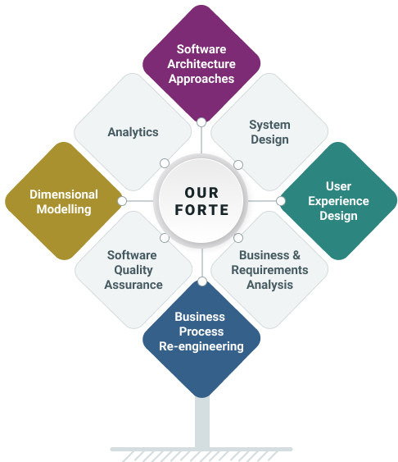
Argusoft has been in business for over 24 years and has successfully undertaken a range of large enterprise-grade projects with small, medium, to very large private, public and government organizations. Argusoft is a software solutions design consultancy that develops, deploys on-cloud/on-premises and grooms such enterprise-class software solutions. Most significantly, our solutions are incredibly protean, ensuring that the business needs are always quickly and easily aligned to the solution. We capitalize on our low-code framework to deliver fully customized solutions that are very stable, quick to configure and hence faster to deliver.

Argonauts (team argusoft!) are trained to think ‘design’ at every step. We architect, design, and code, always keeping our clients' business objectives in mind. We work as total partners, fully shouldering the responsibility of their business enabling software systems or, in the case of software product companies, as trusted technology partners of their core business offering.

Argusoft has successfully accomplished several significant SOA software development projects for Fortune 1000 US and India clients over the last dozen years. It plans to continue its focus on this activity as a turnkey software services provider. Argusoft’s forte is its solution design and technological prowess to build and deploy large enterprise-class software systems successfully. Several of these systems have also been developed and managed by Argusoft for several years. Argusoft has never been restricted by domains or verticals.

Why we do, what we do
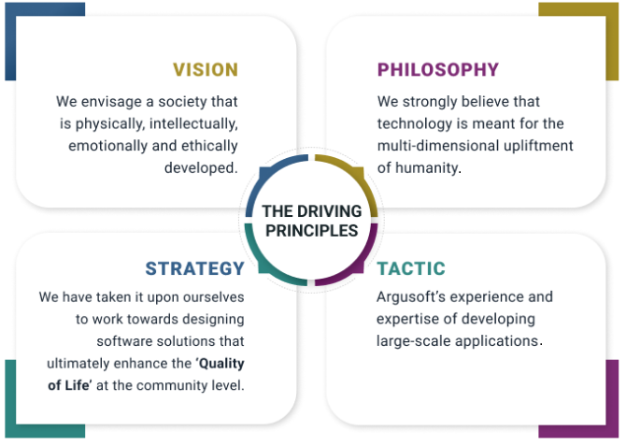

Registration Certificate and GST Certificate
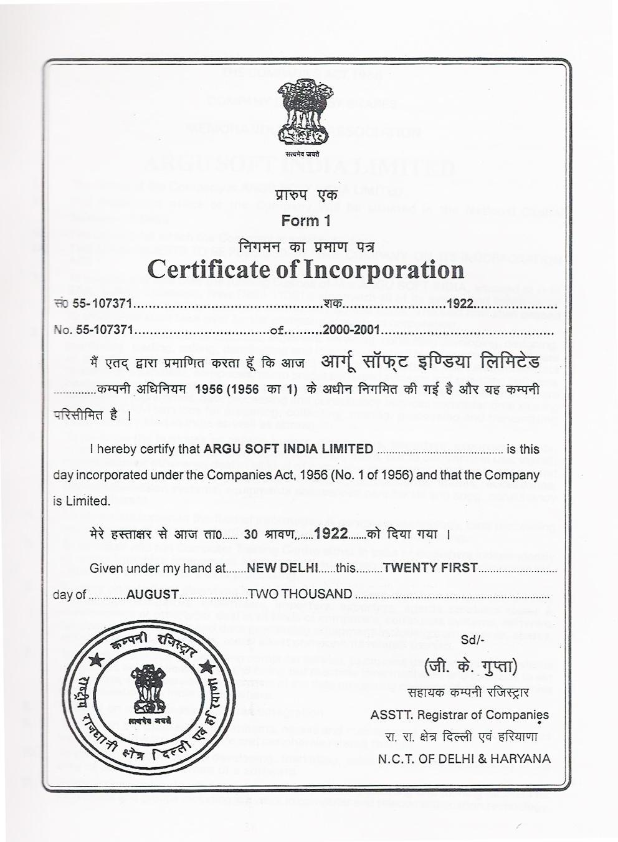

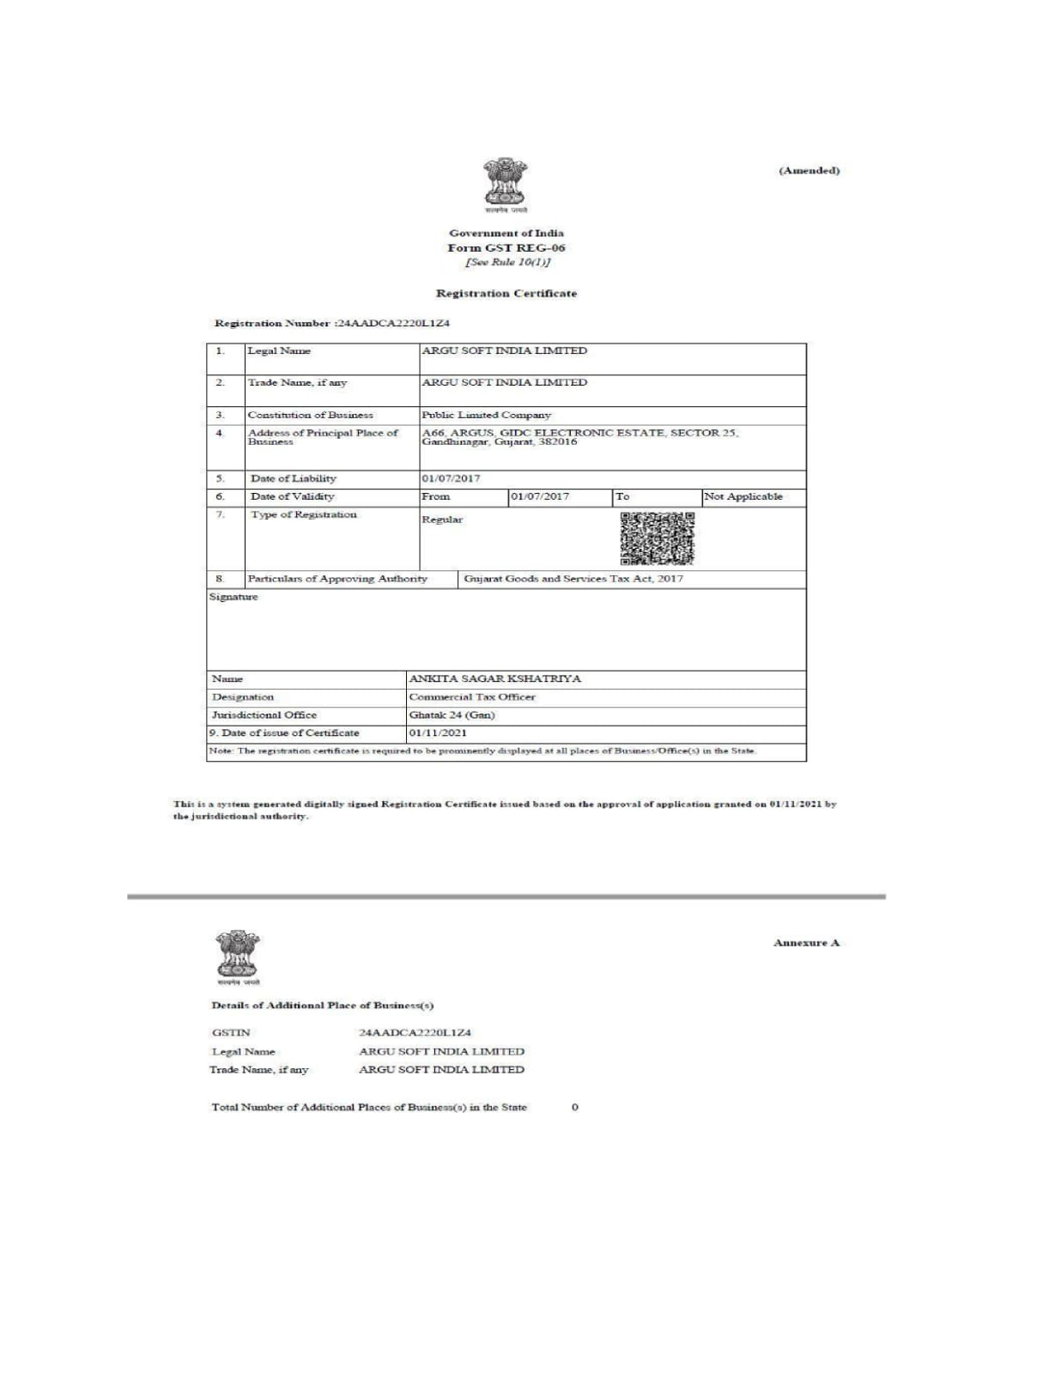

Awards, Certifications and Accreditation
Argusoft has achieved a range of ISO certifications, including
ISO 9001:2015  for Quality Management System (QMS) | ISO/IEC 27001:2003  for Information Security Management System (ISMS), and | ISO 14001:2015  for Environmental Management System
ISO/IEC 20000-1:2011  for IT Service Management (ITSM) | ISO/IEC/IEEE 23026:2015  for Systems and Software Engineering — Engineering and management of Websites for Systems, Software, and Services Information.

Geographical Presence
Argusoft has a global presence in terms of digital solution deliveries. It has designed and implemented solutions in over a dozen countries in five continents. Argusoft provides Consulting, Solution Design, Solution Architecture, Software Solution Development, Business Analysis, QA & Testing, Client Support, and Business Operations from its global delivery centre in India office. It has several partner offices in the US, Middle East, and Japan which are responsible for Business Development activities.
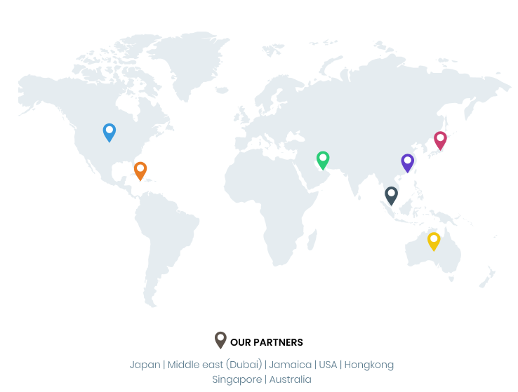
Argusoft - India Operations | Argusoft - US Operations
A-66, Sector 25, GIDC, Gandhinagar,  Gujarat 382016, India | 35463 Dumbarton Ct., Newark,  CA 94560, USA

Annexure 2 : ISO Certifications

Argusoft India

CMMI Level 5 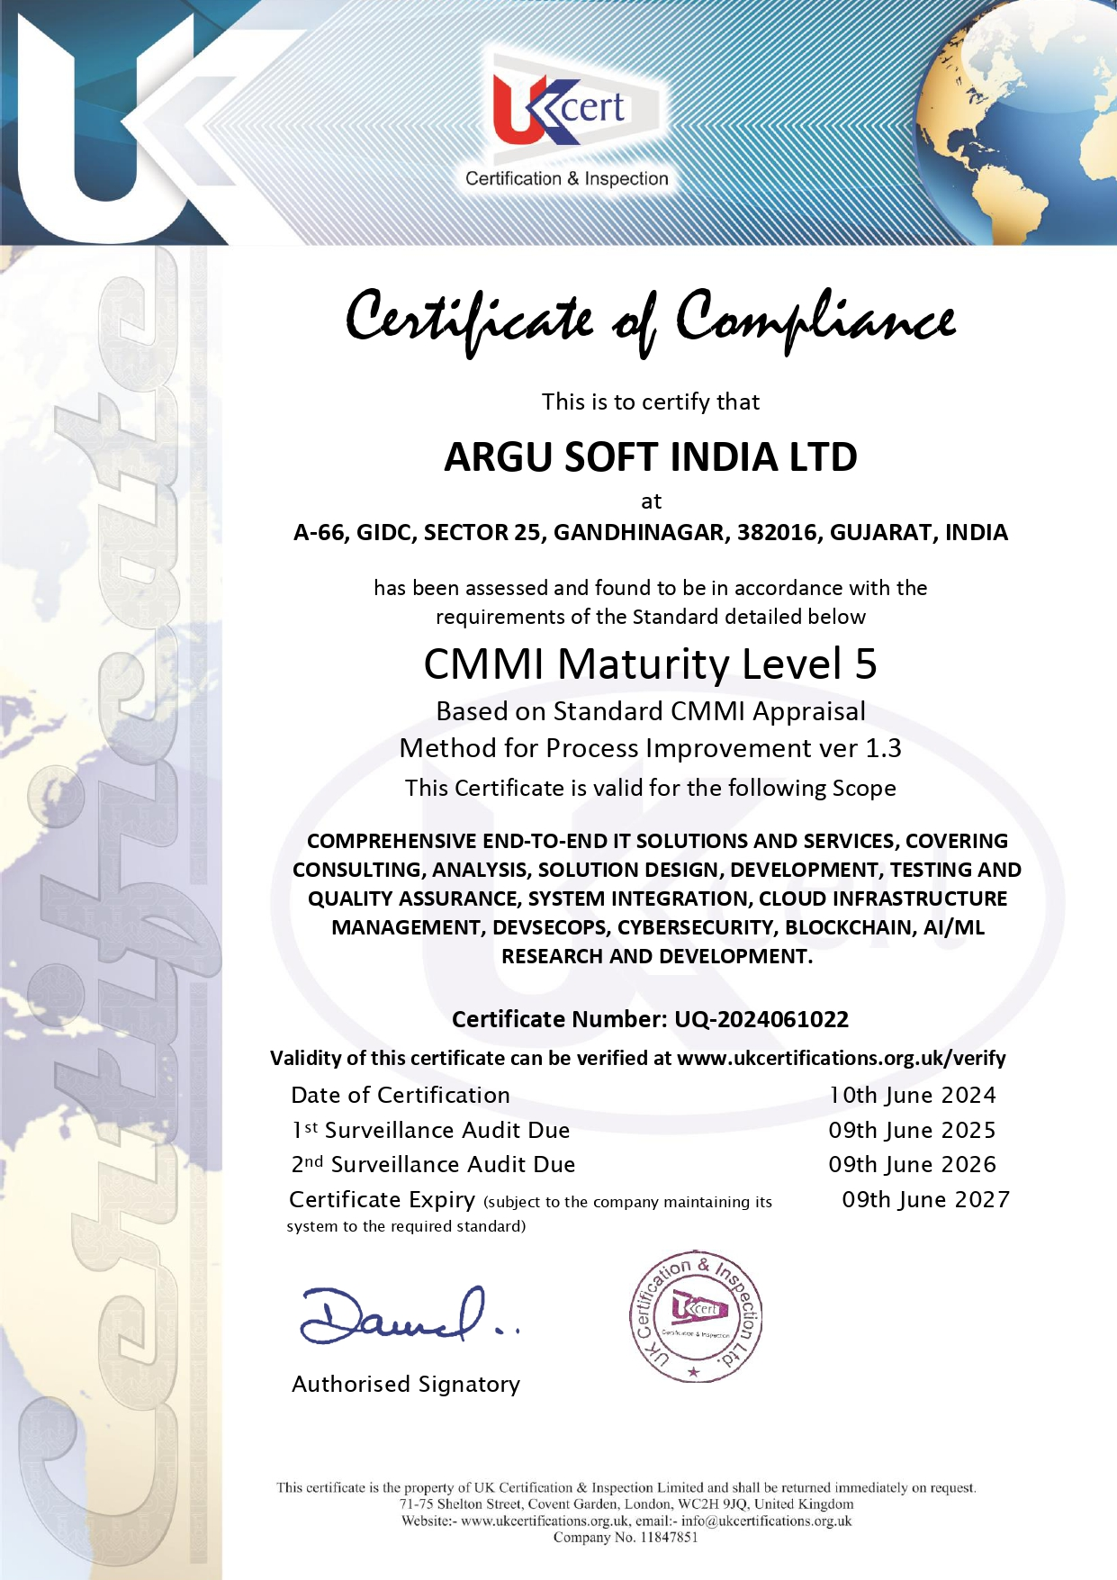

ISO 9001:2015 Quality management system


ISO 14001:2015 Environmental management system

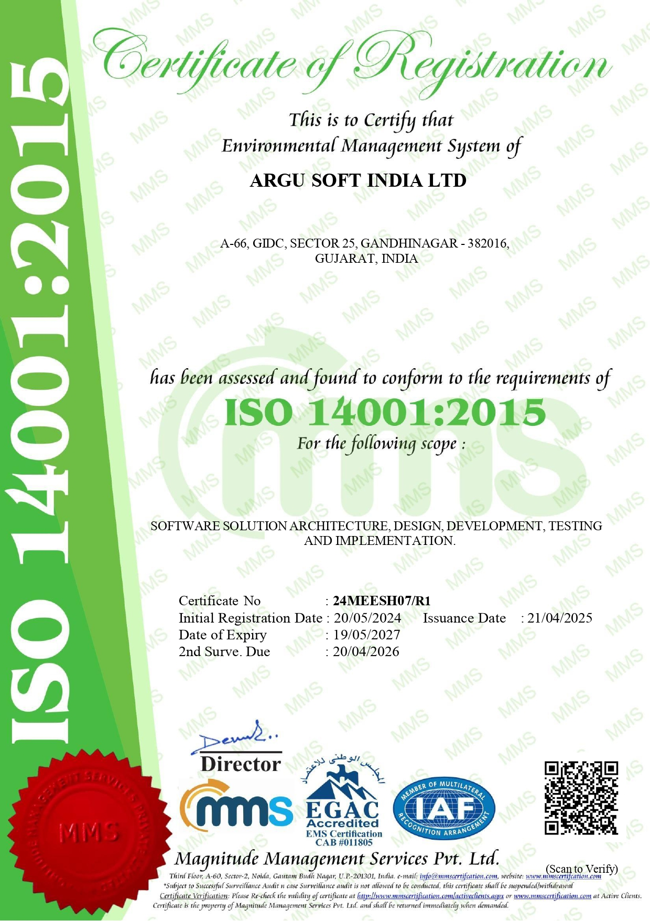

ISO/IEC 20000-1:2018 IT service management (ITSM)


ISO/IEC 27001:2022 Information security management system (ISMS)


ISO/IEC/IEEE 23026:2015 - Engineering and Management of Websites for Systems, Software, and Services Information



MedIT

ISO 20000-1
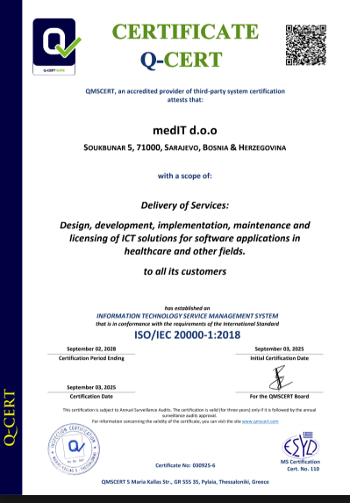

ISO 9001
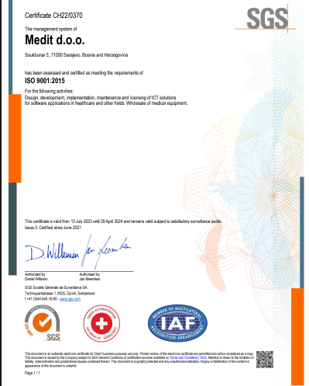

ISO 27001
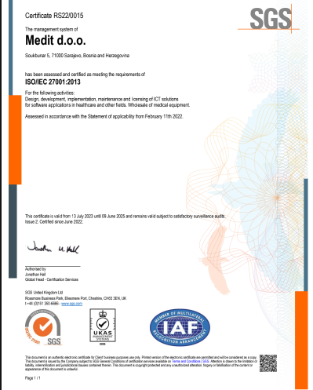

ISO 13485


